


 | Developing a Semi-Dynamic Landslide Susceptibility Decision-Support Dashboard Using Machine Learning for Malaysia

By
LIM TZE JIUN
TP080348
APD3F2605CSDA
A report submitted in partial fulfillment of the requirements for the degree of Bachelor of Computer Science (Hons) (Data Analytics)
at Asia Pacific University of Technology and Innovation.
Supervised by Assoc. Prof. Dr. Raja Rajeswari
2nd Marker: Law Wei Liang

2026

Acknowledgement
I would like to express my sincere gratitude to my supervisor, Assoc. Prof. Dr. Raja Rajeswari, for her guidance, patience and constructive feedback throughout the first stage of my Final Year Project. Her advice helped me refine the project scope, clarify the distinction between landslide susceptibility and official landslide warning, identify suitable datasets and improve the structure of the investigation report. Her comments during supervisory discussions were especially valuable in guiding the introduction, literature review, data-understanding process and initial preprocessing work. I would also like to thank my second marker, Law Wei Liang, for reviewing and assessing this investigation report and for the academic feedback that will support the continued improvement of the project. My appreciation is also extended to the lecturers and staff of Asia Pacific University of Technology and Innovation who provided the guidelines, resources and academic knowledge required to complete this stage of the study. Finally, I would like to thank my family and friends for their encouragement, understanding and continuous support throughout the preparation of this report. Their support motivated me to remain committed while managing the research, documentation and technical work required for the project.
The guideline only requires the acknowledgement to recognise people or parties who contributed to the project and allows it to occupy up to one page. This version follows the senior samples but avoids overly emotional expressions that may sound exaggerated or generic.

Abstract
Landslides remain a serious geohazard in Malaysia, particularly in areas affected by intense rainfall, steep terrain, land-cover change and human modification of slopes. Existing susceptibility maps are commonly based on static or slowly changing environmental conditions and may not clearly represent changes associated with recent or accumulated rainfall. This project aims to develop a semi-dynamic landslide susceptibility decision-support dashboard using machine learning for Malaysia. The project adopts the Cross-Industry Standard Process for Data Mining methodology and integrates historical landslide inventories with rainfall, terrain, land cover, road, waterway and administrative-boundary data. The first stage of the project involved domain research, evaluation of similar systems of landslide, technical investigation, data collection, data understanding and initial preprocessing, while including a total of 1,540 candidate landslide records from Malaysia, Indonesia, Thailand, the Philippines and Singapore were examined. The analysis identified differences in record quantity, temporal coverage, missing event attributes and spatial concentration. Nineteen potential spatial-temporal duplicate records were identified for manual review, while no invalid geometries or missing event dates were found. Malaysia, Indonesia and Thailand were retained for the primary dataset, the Philippines was retained for sensitivity analysis, and Singapore was excluded because it contained only one record. The subsequent environmental-feature extraction, pseudo-absence generation, model development and dashboard implementation will be supported by the prepared workflow. The project contributes to Sustainable Development Goal 11 by supporting landslide awareness, preliminary planning and more accessible communication of susceptibility information.
Keywords - Landslide Susceptibility, Machine Learning, Geographic Information System, Rainfall, Decision-Support Dashboard, Malaysia

SDG Goal 11: Make cities and human settlements inclusive, safe, resilient and sustainable.
Table of Contents
Acknowledgement 2
Abstract 3
List of Figures 7
List of Tables 9
1.0 CHAPTER 1: INTRODUCTION 10
1.1 Introduction 10
1.2 Problem Background 12
1.3 Project Aim 14
1.4 Objective 14
1.5 Scope 14
1.5.1 Tasks to Be Executed 14
1.5.2 Constraints 15
1.6 Potential Benefits 16
1.6.1 Tangible Benefits 16
1.6.2 Intangible Benefits 17
1.6.3 Target Users 18
1.7 Overview of the IR 18
1.7.1 Chapter 1: Introduction 18
1.7.2 Chapter 2: Literature Review 18
1.7.3 Chapter 3: Methodology 19
1.7.4 Chapter 4: Conclusion 19
1.8 Project Plan 19
2.0 CHAPTER 2: LITERATURE REVIEW 24
2.1 Introduction 24
2.2 Domain Research 25
2.2.1 Landslide Hazards and Disaster Risk in Malaysia 25
2.2.2 Landslide Inventory and Data Availability for Susceptibility Modelling 27
2.2.3 Geospatial Conditioning Factors for Landslide Susceptibility 29
2.2.4 GIS Remote Sensing and Machine Learning for Landslide Susceptibility Mapping 33
2.2.5 Landslide Susceptibility Visualization and Decision-Support Dashboards 39
2.3 Similar Systems 42
2.3.1 Landslide Hazard Assessment for Situational Awareness Version 2 42
2.3.2 Machine Learning-Based Rainfall-Induced Landslide Susceptibility and Short-Term Early Warning Assessment in South Korea 44
2.3.3 Automated Landslide-Risk Prediction Using Web Geographic Information System and Machine Learning 46
2.3.4 Landslide Information System of the Republic of Korea 47
2.3.5 Comparison of System Features 49
2.4 Technical Research 52
2.4.1 Hardware and Software Identification and Justification 52
2.4.2 Integrated Development Environment (IDE) Chosen 55
2.4.3 Libraries and Tools Chosen 55
2.4.4 Database Management System Chosen 57
2.4.5 Operating System Chosen 58
2.4.6 Web Server Chosen 58
2.5 Summary 59
3.0 CHAPTER 3: METHODOLOGY 60
3.1 Introduction 60
3.2 System Development Methodology 61
3.2.1 Introduction of CRISP-DM Methodology 61
3.2.2 Methodology Choice and Justification 62
3.2.3 Phases, Activities and Processes of CRISP-DM 66
3.3 Data Collection 69
3.4 Initial Data Understanding and Data Pre-processing 72
3.4.1 Data Understanding 72
3.4.2 Data Pre-processing 83
3.5 Summary 90
4.0 CHAPTER 4: Conclusion 91
4.1 Achievements of the First Part of the Project 91
4.2 Adequacy of the Investigation and Research 92
4.3 Research and Design Gaps for Further Improvement 93
5.0 References 95
6.0 Appendix 104
Appendix A: PPF – Title Registration Proposal 104
Appendix B: Ethics Forms (Fast Track) 106
Appendix C: Log Sheets 110
Appendix D: Gantt Chart 115
Appendix E: Turnitin Similarity Report 116

List of Figures
Figure 1 Geographic Scope of the Proposed Malaysia-Wide Landslide Susceptibility Study 10
Figure 2 Geographic Distribution of Selected Malaysian Landslide Susceptibility Studies Reviewed 25
Figure 3 Influence of Landslide Inventory Quality on Susceptibility Modelling 27
Figure 4 Proposed Information Components of a Landslide Susceptibility Decision-Support Dashboard 39
Figure 5 Comparison of Three-Day, Two-Day and One-Day LHASA Forecasts with Near-Real-Time Landslide Probability Estimates in Vanuatu (Khan et al., 2022) 42
Figure 6 South Korean Landslide Susceptibility and Early Warning Workflow (Lee et al., 2025) 44
Figure 7 Automated WebGIS Interface for Landslide-Risk Prediction in Chiang Rai, Thailand (Tengtrairat et al., 2021) 46
Figure 8 Main Interface of the Landslide Information System of the Republic of Korea (Eu et al., 2024) 47
Figure 9 The Structure of CRISP-DM 61
Figure 10 Source Code for Loading and Summarising Candidate Landslide Inventories 72
Figure 11 Candidate Landslide Inventory Structure and Record Count by Country 73
Figure 12 Source Code for Assessing the Malaysia Landslide Inventory 73
Figure 13 Overview and Quality Summary of the Malaysia-Only Landslide Inventory 73
Figure 14 Historical Landslide Records in Malaysia by Year 74
Figure 15 Source Code for Cross-Country Record and Temporal Comparison 75
Figure 16 Candidate Landslide Record Counts and Temporal Coverage by Country 75
Figure 17 Cross-Country Comparison of Candidate Record Counts and Annual Landslide Distributions 76
Figure 18 Source Code for Assessing Inventory Quality and Duplicate Candidates 76
Figure 19 Cross-Country Data Quality and Potential Duplicate Assessment 77
Figure 20 Potential Spatial-Temporal Duplicate Landslide Records for Manual Review 77
Figure 21 Source Code for Comparing Landslide Event Attributes 78
Figure 22 Dominant Recorded Trigger, Landslide Category and Event Size by Country 79
Figure 23 Source Code for Validating and Mapping Landslide Locations 80
Figure 24 Valid Spatial Records and Unique Rounded Locations by Country 80
Figure 25 Spatial Distribution of Candidate Historical Landslide Records in Southeast Asia 81
Figure 26 Source Code for Summarising Candidate Dataset Decisions 82
Figure 27 Data Understanding Summary and Candidate Country Selection Assessment 82
Figure 28 Candidate Country and Record Selection 83
Figure 29 Candidate-country selection decisions and supporting justifications 83
Figure 30 Original landslide inventory counts and selection status before preprocessing 84
Figure 31 Source Code for Duplicate Candidate Review and Handling 84
Figure 32 Duplicate Candidate Group Summary 85
Figure 33 Duplicate Records for Manual Review 85
Figure 34 Source Code for Missing and Invalid Record Handling 86
Figure 35 Essential Record Validity Assessment 86
Figure 36 Source Code for Inventory Schema and CRS Standardisation 87
Figure 37 Standardised Inventory Field Structure 88
Figure 38 Standardised Malaysia Inventory Sample 88
Figure 39 Source Code for Inventory Integration and Technical Validation 89
Figure 40 Final Inventory Validation Results 89
Figure 41 Post-Preprocessing Country Record Counts 89
Figure 42 Complete Preprocessing Audit Trail 90
Figure 43 Cleaned Records by Country 90
Figure 44 PPF-Title Registration Proposal 96
Figure 45 Ethics Form 100
Figure 46 Log Sheet 1 101
Figure 47 Log Sheet 2 102
Figure 48 Log Sheet 3 103
Figure 49 Gantt Chart 103
Figure 50 Turnitin Similarity Report 103

List of Tables
Table 1 Project Plan 20
Table 2 Landslide Inventory Challenges and Planned Methodological Responses 28
Table 3 Candidate Geospatial Conditioning and Triggering Factors Reviewed for the Proposed Study 31
Table 4 Comparative Assessment of Machine-Learning Models for Landslide Susceptibility Mapping 34
Table 5 Comparative Analysis of Existing Landslide Information and Decision-Support Systems 50
Table 6 Recommended Hardware Requirements for the Proposed Dashboard 53
Table 7 Main Software Requirements and Their Intended Uses 54
Table 8 Proposed Libraries and Tools for Data Processing, Modelling and Visualisation 55
Table 9 Comparison of CRISP-DM, KDD, SEMMA and Waterfall 63
Table 10 Alignment Between Project Objectives and CRISP-DM Phases 65
Table 11 Candidate Data Sources, Characteristics and Intended Uses 70

CHAPTER 1: INTRODUCTION

Introduction
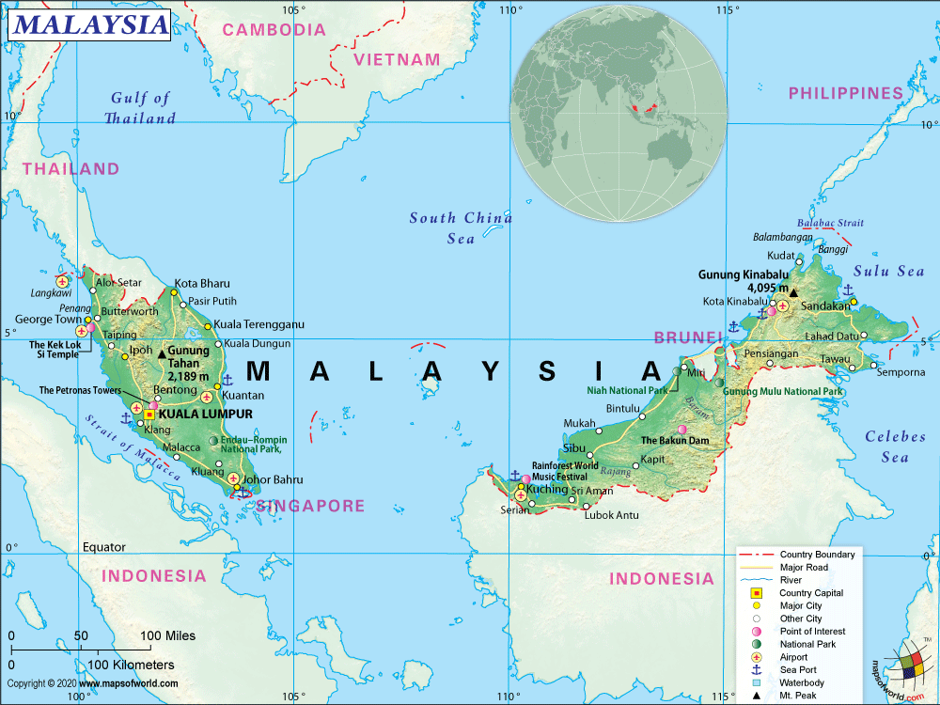
Figure 1 Geographic Scope of the Proposed Malaysia-Wide Landslide Susceptibility Study
One of the most dangerous geohazards exists in the tropical and mountainous areas, which may result in loss of life, destruction of infrastructure, disruption of transport, environmental degradation, and financial losses, which namely landslides. The monsoon rains, steep topography, weathered soil conditions, changes in land use, and urbanization in Malaysia will influence landslide occurrence. The natural terrain conditions that have been modified by these factors will reduce the slope stability, especially in hillside areas, road embankments, and developed slopes. (Maturidi et al., 2021; Affandi et al., 2023).
Malaysia has been experiencing several major incidents that demonstrated the severity of landslide hazards. Several landslides have been taking place in Malaysia from the northeast monsoon season of 2021 to 2022, out of which Selangor recorded the highest number of cases. The destructive impact of rainfall, slope instability, and exposure of people and infrastructure has been highlighted through the case of the Batang Kali landslide in Hulu Selangor in December 2022, as the incident resulted in 31 fatalities, including 13 children (Mohd Noh et al., 2024). The persistence of the threat of landslide hazards is evident from recent slope failure incidences, especially for the communities, infrastructure, and disaster management agencies (Jun, 2024; The Star, 2025).
The effective landslide management that is safer, more resilient, and more sustainable communities, which is about Sustainable Development Goal 11, especially in relation to the goal of establishing safer, more resilient, and sustainable settlements. Assessing landslide susceptibility, risk communication, and disaster preparation will help in minimizing the exposure of the community and government to the risks posed by slope failures. Hazard identification, public awareness, preparedness, and disaster risk reduction have also been emphasized in the slope management initiatives of Malaysia. Therefore, accessible geospatial decision-support tools may be helpful in making decisions related to planning and preparation for heavy rains.
The occurrence of landslides is dependent on interaction between the terrain, hydrology, land cover, and short-term triggering conditions. The slope angle and the elevation of the area show the physiographic features of the terrain, while the aspect determines the exposure of the area to rainfall, sunlight, vegetation, and soil moisture levels. Land-cover attributes may serve to reinforce stability with vegetation or destabilize it with deforestation and urbanization (Renata Pacheco Quevedo et al., 2023). The roads construction might disturb slope geometry and drainage, and proximity to waterways may facilitate erosion and slope toe undercutting (Selamat et al., 2022b). Rainfall is the triggering event that increases soil moisture content and pore water pressure in areas prone to failure (Maturidi et al., 2021). These variables that identify landslide-prone terrain are used on the Malaysia studies conducted in areas such as Kuala Lumpur, Canada Hill, the Langat Basin, and Hulu Langat (Affandi et al., 2023; Daniel et al., 2021; Selamat et al., 2022a; Syams et al., 2025). However, most existing research focuses on either the district or state level, creating a need for a broader Malaysia-wide assessment.
This project proposes a semi-dynamic landslide susceptibility with the rainfall-responsive decision-support dashboard for Malaysia, which will be developed through the use of geospatial data and satellite data on rainfall. The proposed system will analyze factors such as accumulated rainfall, slope, elevation, and other geographical factors to classify different levels of susceptibility and identify landslide-prone areas across Malaysia through an interactive Geographic Information System dashboard. The stable and slow geospatial parameters will be used to assess the underlying susceptibility of each area, while the most dynamic parameter, that is the rainfall data collected in the recent one to thirty day will serve as the changing component of the warning indicator. The resulting dashboard will provide landslide susceptibility information to support disaster preparedness and communication efforts regarding landslide susceptibility in a clear and effective manner.

Problem Background
The hillside and rapidly urbanising regions exposed to heavy rainfall, which interact with modifications to slope, terrain steepness, weathering of materials and changes in land cover in Malaysia, continue to experience recurring landslide incidents (Affandi et al., 2023). Landslide susceptibility mapping has been extensively used to determine areas where environmental factors such as slope, elevation, rainfall, land use, geology, and other factors related to drainage to find areas that are likely to be prone to slope failure (Murthy et al., 2023). However, the static or slowly changing terrain, geological, and land surface conditions are produced for susceptibility maps. Although, these maps are useful to the long-term land use planning and preliminary hazard assessment, they might fail to reflect the short term changes of environmental conditions.
Static landslide susceptibility maps provide a fixed representation of the relative spatial tendency or slope failure based mainly on conditioning factors such as slope, elevation, aspect, land cover and proximity to roads or waterways. The environmental parameters that might influence the configuration of the terrain, drainage, protection of the vegetation cover, and disturbances are essential. However, the chances of failures occurring can rise where vulnerable terrains are exposed to intense or prolonged rainfall. Kang et al. (2024) combined parameters like elevation, slope, aspect, lithology, land cover, vegetation, soils, and rainfall in the modeling of rainfall-triggered landslides, indicating that rainfall should be evaluated in combination with the existing environmental parameters.
This limitation in a gap between the long duration of susceptibility mapping and the short duration of disaster preparedness needs. Static maps might correctly depict the unfavorable slope, altitude, land cover, and proximity condition in that area, while the classification will always be constant regardless of whether the area is experiencing dry or wet seasons. The rainfall data and landscapes shown on the Space-time models can be analyzed together to represent the changing landslide conditions over time and location (Lim et al., 2024). As a result, the consideration of changing rainfall that not included in the susceptibility information will help determine areas susceptible to landslides but will not be able to detect the increase in warning conditions due to recent or accumulated rainfall.
The effectiveness of landslide modelling is further influenced by the quality and comprehensiveness of the landslide inventories used for training and validation. Historical landslide inventories may contain incomplete records, uneven geographic coverage, temporal gaps and reporting bias. These limitations can influence model training, validation and national generalisation. Recent studies indicate that incompleteness of the landslides inventories can significantly influence model performance and the resulting susceptibility patterns(Tan et al., 2024). The effect of missing data that is spatially clustered can be particularly serious, which certain terrains and environmental conditions could become under-represented within the modeling process.
Landslide data may be difficult to understand and apply by policymakers and other users without technical knowledge if the outputs are solely provided via static maps, technical reports, or data sets separately. An example of a prototype in Malaysia is thus needed that integrates historical landslide information with selected terrain, geological, land-cover, hydrological, anthropogenic and triggering-condition variables.into a unified process of machine learning and GIS. The semi-dynamic dashboard to be developed will provide information regarding susceptibility of various areas along with a rainfall-based alert system that allows the users to xplore historical events, susceptibility levels and recent rainfall conditions through one interface.
Therefore, there is a need to develop a semi-dynamic landslide susceptibility decision-support dashboard that integrates rainfall data with geospatial conditioning factors. The proposed system can classify landslide susceptibility levels and visualise landslide-prone areas with the integration of rainfall data, terrain features based on Digital Elevation Model, land-use information, historical landslide records, and machine learning techniques through an interactive GIS-based dashboard. This approach aims to enhance landslide risk communication through the simplification of rainfall-related changes in warning conditions and spatial susceptibility patterns that are easier to interpret for disaster preparedness and mitigation purposes.

Project Aim
To develop a semi-dynamic landslide susceptibility decision-support dashboard using machine learning for Malaysia.

Objective
- To identify relevant conditioning and triggering factors associated with landslide susceptibility in Malaysia.
- To analyse spatial and statistical relationships between selected environmental conditions and historical landslide occurrences.
- To evaluate machine-learning models for classifying landslide susceptibility in Malaysia.
- To design an interactive dashboard for visualising susceptibility patterns and supporting landslide-related decision-making.

Scope

Tasks to Be Executed
Data Collection and Integration
NASA COOLR, GPM IMERG V07, SRTM, Dynamic World, and OpenStreetMap can collect the historical landslides, rainfall, terrain, land cover, roads, and waterways, and then be integrated within the Malaysia boundary. NASA COOLR provides an open repository that includes the landslide records from the Global Landslide Catalog and community-contributed sources.
Data Preparation and Feature Engineering
The features of rainfall accumulation, elevation, slope, aspect, land-cover class, distance-to-road, and distance-to-waterway will be converted from the dataset after being cleaned and spatially aligned. The positive and assumed non-events samples would then be prepared for modelling, while the selection of non-landslide samples needs to be careful, which might affect the reliability of the model and susceptibility patterns through different sampling strategies.
Machine-Learning Modelling
Logistic Regression will be the first model that will be created as the baseline model, while Random Forest will be used as the classifier. The way to reduce data leakage during model evaluation is through separating records from identical locations by grouped or spatial validation.
Warning Indicator and Dashboard Development
Susceptibility will be modeled based on rainfall and geospatial variables in the chosen model. The dashboard will present susceptibility probabilities or classes, historical occurrences and supporting environmental information available for the prototype.
Testing and Documentation
The quality of the dataset, data pre-processing, modeling performance, functions of the dashboard, and visualizations will be tested. The report will cover data sources, pre-processing techniques, model choices, evaluation results, limitations, and recommended improvements for the future.

Constraints
Data and Geospatial Constraints
This project relies on the publication of a dataset, which might contain incomplete landslide records, different spatial accuracy and differences in update periods. The data of current land cover, road and waterway may not represent conditions on historical event dates.recover
Modelling Constraints
The limitation of national generalization might be affected by the limited landslide database. The control samples are based on events that are assumed not to be landslides but not proven to be landslides, while the model evaluates the statistical susceptibility without direct measurement of the soil strength, geology, water pressure, and ground displacement. As a result, the uncertainty of the selected non-landslide will affect the result of the landslide susceptibility.
Warning and Technical Constraints
The rainfall can be updated more frequently than the variables of terrain and land cover, which show a semi-dynamic system. IMERG provides satellite-derived precipitation estimates, which do not necessarily reflect the rainfall in the individual slopes.
Project Boundaries
It applies to Malaysia and only provides regional decision-making support and not engineering assessments. No physical sensors would be deployed, and it is not intended to substitute for warning systems, evacuations, emergency response decisions, or geotechnical investigations.

Potential Benefits

Tangible Benefits
- Malaysia-wide susceptibility visualization
The dashboard will display landslide susceptibility probabilities or classes across Malaysia, allowing users to compare spatial patterns between states and regions. This benefit will be whether the susceptibility layer for the whole country will be successfully generated for all the states and federal territories in Malaysia. The completeness of the visualisation can also be assessed by checking the percentage of valid Malaysian locations or grid cells for which susceptibility results are available.
- Integrated geospatial dataset
The project will produce a structured dataset that combines historical landslide records, rainfall, terrain, land cover, roads and waterways. The performance indicator for this benefit is the number of successfully integrated datasets, number of final model-ready records and the completeness of the required environmental features.
- Lower infrastructure cost
The project will use open datasets, open-source libraries and an existing personal computer instead of deploying physical monitoring equipment. This benefit is the documentation of the cost of software licenses, datasets, and extra hardware costs incurred when developing the prototype.
- Interactive decision-support function
The dashboard will combine maps, filters, rainfall summaries, historical records and susceptibility information within one interface. This benefit will be measured through functional testing of the implemented dashboard components.
- Support for planning activities
The susceptibility map will support the preliminary identification of areas that may require further inspection or professional assessment. This benefit is whether the system will enable ranking or classification of locations based on susceptibility and allow identification of higher susceptibility locations.
- Reproducible analytical workflow
The project will produce documented preprocessing, feature-engineering, modelling and evaluation procedures that can be reused with updated inventories or environmental data. This benefits whether the workflow can be successfully run again to produce the required data sets, output of model and visualization.

Intangible Benefits
- Improved landslide awareness
Clear maps and warning indicators help non-technical users understand how terrain conditions and recent rainfall jointly influence landslide susceptibility.
- Better susceptibility awareness
The dashboard translates complex model outputs into interpretable visual categories that can support communication among agencies, planners, and communities.
- Data-driven preparedness culture
The project encourages the use of historical evidence, satellite observations, and analytical models in disaster-preparedness discussions.
- Academic contribution
The study documents practical challenges involving incomplete inventories, pseudo-absence sampling, spatial validation, and semi-dynamic warning design.
- Support for Sustainable Development Goal 11
Improved hazard awareness and spatial planning information contribute to safer, more resilient, and better-prepared communities.

Target Users
The target users of this system include local authorities and disaster management agencies responsible for monitoring and responding to landslide hazards, urban planners and developers who need to identify high-risk slope areas before carrying out construction activities, and local communities and residents living in hillside areas who benefit from increased awareness of environmental risks surrounding their neighbourhoods (Tengtrairat et al., 2021; Stanley et al., 2021).

Overview of the IR

Chapter 1: Introduction
This chapter introduces the landslide hazards in Malaysia, explaining the relation with Sustainable Development Goal 11. Some constraints such as static susceptibility mapping, incomplete landslide inventories, uncertainty in non-event sampling, and conventional random validation will be proposed in this chapter. This chapter has also included the project aim, objectives, scope, potential benefits, target users, report structure, and project plan.

Chapter 2: Literature Review
This chapter reviews the landslide hazard, inventory availability, rainfall triggering, geospatial conditioning, machine learning-based landslide susceptibility modeling, and decision-making visualization of Malaysia. Additionally, the present study will be compared to the existing landslide system, and the suitable design constraints will be discussed.This chapter has also justified the selected datasets used, programming language, Geographic Information Systems, machine learning libraries, and dashboards.

Chapter 3: Methodology
The chapter describes the selected data analytics approach, as well as its usage in the study. Specifically, it explains the procedure for gathering information on COOLR landslides, IMERG precipitation, Shuttle Radar Topography Mission terrain, Dynamic World land cover, and OpenStreetMap roads and rivers. The chapter also discusses data understanding, exploratory visualization, missing values analysis, duplicate detection, creation of control samples, geospatial transformations, and feature engineering.

Chapter 4: Conclusion
The current chapter offers an overview of the research conducted at the first stage of the project and evaluates whether adequate research, data set validation, and methodology have been undertaken. It also pinpoints what other problems should be solved during the development stage.

Project Plan

Table 1 Project Plan
No. | Task Name | IR Chapter | Duration | Start | Finish | Predecessors
1 | Project Initiation |  | 4 days | Wed 05/20/26 | Mon 05/25/26
2 | Confirm Project Title and Research Direction |  | 1 day | Thu 05/21/26 | Thu 05/21/26
3 | Prepare Project Proposal Form |  | 4 days | Wed 05/20/26 | Mon 05/25/26
4 | Business Understanding |  | 19 days | Mon 06/08/26 | Thu 07/02/26
5 | Define Problem Background | 1.2 | 7 days | Mon 06/08/26 | Tue 06/16/26
6 | Domain Research | 2.2 | 7 days | Wed 06/17/26 | Thu 06/25/26
7 | Review Similar Systems and Related Studies | 2.3 | 7 days | Wed 06/17/26 | Thu 06/25/26
8 | Select and Justify Methodology | 3.1–3.2 | 2 days | Fri 06/26/26 | Mon 06/29/26
9 | Define Project Aim | 1.3 | 1 day | Tue 06/30/26 | Tue 06/30/26
10 | Define Measurable Objectives | 1.4 | 1 day | Tue 06/30/26 | Tue 06/30/26
11 | Define Scope, Constraints, Exclusions and Target Users | 1.5 | 1 day | Tue 06/30/26 | Tue 06/30/26
12 | Define Potential Benefits and SDG Contribution | 1.6 | 1 day | Tue 06/30/26 | Tue 06/30/26
13 | Conduct Technical Research | 2.4 | 2 days | Wed 07/01/26 | Thu 07/02/26
14 | Data Understanding |  | 3 days | Fri 07/03/26 | Tue 07/07/26
15 | Identify and Acquire Landslide Inventory and Environmental Data | 3.3 | 1 day | Fri 07/03/26 | Fri 07/03/26
16 | Review Dataset Structure and Spatial Reference Systems | 3.4.1 | 1 day | Mon 07/06/26 | Mon 07/06/26 | 15
17 | Assess Record Distribution, Temporal Coverage and Data Quality | 3.4.1 | 2 days | Mon 07/06/26 | Tue 07/07/26
18 | Data Preparation |  | 37 days | Wed 07/08/26 | Mon 08/03/26
19 | Review and Handle Invalid, Missing and Duplicate Records | 3.4.2 | 2 days | Wed 07/08/26 | Thu 07/09/26
20 | Standardise Inventory Schema, Dates, Coordinates and CRS | 3.4.2 | 6 days | Wed 07/08/26 | Sun 07/13/26
21 | Integrate Selected Country Inventories and Validate Records | 3.4.2 | 8 days | Wed 07/08/26 | Wed 07/15/26
22 | Document Data Understanding and Initial Preprocessing Results | 3.3–3.4.7 | 15 days | Mon 07/20/26 | Mon 08/03/26
23 | Modelling |  | 14 days | Mon 09/21/26 | Thu 10/08/26
24 | Prepare Model-Ready Dataset and Configure Baseline Models |  | 1 day | Mon 09/21/26 | Mon 09/21/26
25 | Train Logistic Regression, Random Forest and Candidate Models |  | 7 days | Tue 09/22/26 | Wed 09/30/26 | 24
26 | Tune Hyperparameters and Refine Model Pipelines |  | 4 days | Thu 10/01/26 | Tue 10/06/26 | 25
27 | Compare Model Configurations and Select Candidate Model |  | 2 days | Wed 10/07/26 | Thu 10/08/26 | 26
28 | Evaluation |  | 8 days | Mon 10/12/26 | Wed 10/21/26
29 | Evaluate Model Performance |  | 2 days | Mon 10/12/26 | Tue 10/13/26
30 | Analyse Confusion Matrices, Recall, Precision and Class Performance |  | 2 days | Mon 10/12/26 | Tue 10/13/26
31 | Conduct Spatial Validation and Cross-Country Sensitivity Testing |  | 4 days | Thu 10/15/26 | Tue 10/20/26
32 | Conduct Error Analysis and Select the Final Model |  | 1 day | Wed 10/21/26 | Wed 10/21/26
33 | Deployment |  | 24 days | Mon 10/26/26 | Thu 11/26/26
34 | Prepare Final Susceptibility and Rainfall Indicator Outputs |  | 4 days | Mon 10/26/26 | Thu 10/29/26
35 | Develop the Interactive Landslide Decision-Support Dashboard |  | 7 days | Fri 10/30/26 | Mon 11/09/26
36 | Integrate Model Predictions, Maps, Filters and Rainfall Indicators |  | 3 days | Tue 11/10/26 | Thu 11/12/26
37 | Conduct Dashboard Functional, Usability and Performance Testing |  | 3 days | Fri 11/13/26 | Tue 11/17/26
38 | Finalise Documentation and Demonstration |  | 7 days | Wed 11/18/26 | Thu 11/26/26

CHAPTER 2: LITERATURE REVIEW

Introduction
This chapter reviews the theory, analysis and technical foundations in the development of the proposed semi-dynamic landslide susceptibility decision-support dashboard for Malaysia. The landslide hazards in the Malaysian context, the availability and limitations of historical landslide inventories and the environmental conditions related to slope failure are examined in the domain research. While the terrain, land cover, roads and rainfall with dynamic triggering factors are relatively stable conditions that need to be particularly taken attention to their interactions. Furthermore, the chapter reviews the Geographic Information Systems, remote sensing and machine-learning techniques that apply on the landslide susceptibility modelling. The confirmation of useful design implications for the proposed dashboard can be through the evaluation of data sources, functions, strengths and limitations based on existing landslide information platforms and related studies. Finally, the hardware, software, development environment, geospatial tools, machine-learning libraries and deployment technologies that are suitable for implementing the project are assessed by technical research. These findings show the conceptual and technical basis for the methodology presented in Chapter 3.

Domain Research

Landslide Hazards and Disaster Risk in Malaysia
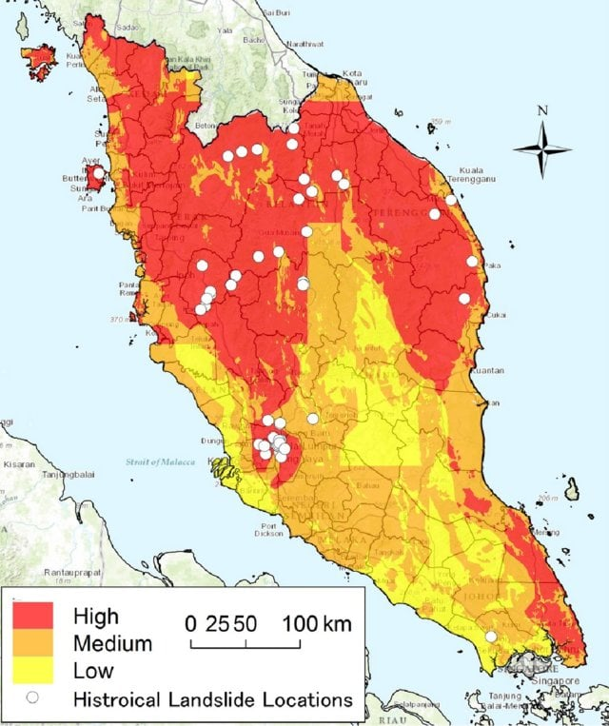
Figure 2 Geographic Distribution of Selected Malaysian Landslide Susceptibility Studies Reviewed
Landslides are significant geohazards that may cause fatalities, infrastructure damage, traffic disruption, environmental degradation and economic losses. Their occurrence is influenced by interactions among intense rainfall, steep terrain, highly weathered geological materials, land-cover change, slope modification and rapid urban development in tropical countries such as Malaysia. Artificially developed slopes, embankments and cut-and-fill slopes are rendered unstable by the construction activities, which affect the natural terrain and drainage (Affandi et al., 2023). Rainfall may contribute to increased soil moisture and pore water pressure, while failure is also dependent on the slope morphology, geology, surface geology, vegetation cover and human activities. Thus, the triggering of landslides should not be associated with rainfall or any single factor.
The terrain and environmental conditions have determined the relative spatial tendency of an area to experience landslide occurrence, which is called landslide susceptibility. It only identifies areas at higher susceptibility to landslides. Landslide Hazard takes into account the time probability of occurrence, the frequency or magnitude of the occurrence, while Landslide Risk involves exposure and vulnerability of human life and property. The model for susceptibility that does not directly give estimates of casualties, damage or expected losses shows that the maintenance of distinction is important. The proposed project therefore focuses on landslide susceptibility rather than complete hazard or risk assessment.
Landslide susceptibility mapping has received extensive investigation in Malaysia. Murthy et al. (2023) identified Geographic Information System-based studies in Selangor, Kuala Lumpur, Penang, Perak, Pahang, Kelantan, Sabah and Sarawak. Their review found that the slope was revealed to be the most prevalent factor, while Logistic Regression, frequency ratio, Artificial Neural Network, and weighted overlay were among the most widely employed methods (Murthy et al., 2023). It clearly shows that improvement is still required in national data integration, model validation and the practical communication of results, even though the Malaysian susceptibility research already considers multiple analytical approaches.
Moreover, the relative importance of landslide causative factors depends on the local environmental conditions have shown from the studies performed at the regional scale. Selamat et al. (2022b) have combined various factors like terrain, geological, hydrological, anthropogenic and rainfall into one model named Artificial Neural Network in the Langat River Basin. The integration of factors like slope, elevation, lithology, rainfall and proximity to roads and rivers should be considered together instead of individually (Selamat et al., 2022b). Affandi et al. (2023) highlighted the spatial validation in the heterogenous geological setting of Kuala Lumpur whereas have used statistical analysis and expert consultation to model the unique geological and geomorphological features of Canada Hill, Sarawak. Collectively, these studies show that regional models are able to give local evidence but that the factors involved and their modelling outcomes cannot be generalized for the whole of Malaysia.
The vast majority of Malaysian vulnerability studies are carried out based on a single city, district, island, river basin or state. There are differences between Peninsular Malaysia, Sabah and Sarawak regarding landscape, geological setting, vegetation, development pressure and climate, which implies that the impact of a particular parameter may be different in another locality. The concentration of the area reduces the possibility of making consistent comparisons across the country and supports the need for a broader Malaysia-wide investigation. The integration of available historical and environmental information through a consistent machine-learning framework and an interactive susceptibility dashboard is addressed by this research project. The system is intended to support awareness, spatial comparisons, and initial planning with respect to Sustainable Development Goal 11, but it will never replace the place of any official warnings, decision-making, or professional geotechnical assessments.

Landslide Inventory and Data Availability for Susceptibility Modelling
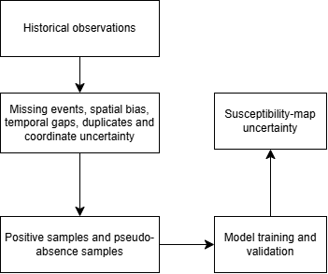
Figure 3 Influence of Landslide Inventory Quality on Susceptibility Modelling
The monsoon rainfall, hilly terrain, urban development, a tropical climate, and highly weathered soil conditions are the features of Malaysia which is exposing the country to landslide hazard. Typically, landslides are triggered by rainfall, slope instability, changes in land use and construction works, particularly in hilly and mountainous regions and rapidly developing urban areas. It affects the people who live in remote mountainous areas, urban and semi-urban regions become dangerous, showing that roads, people, and buildings are located near unstable slopes (Affandi et al., 2023; Murthy et al., 2023).
Inventory incompleteness is a recognised issue in tropical environments. Rapid vegetation regrowth, erosion, redevelopment and slope repair may conceal evidence of earlier failures. Affandi et al. (2023) explained that rapid urbanization and tropical processes might make it difficult to develop inventories because they will remove the evidence on the field. If there are fewer events documented in some areas, it might be thought that some geologic or terrain features were not properly captured by the model, which will cause the model to incorrectly identify those environments as having low susceptibility (Affandi et al., 2023).
Moreover, several studies have used multi-source data in Hulu Langat and Langat River Basin areas.to solve those inventory gaps. For example, the combination of historical archives and satellite imagery interpretation has explained the recent mapping of the Langat Basin and confirmed that 140 landslide locations have been identified, which applied an Artificial Neural Network (ANN) model with high accuracy (Selamat et al., 2022b). Moreover, the case of the 2021 debris flow event proves that there is an underestimation of risk in river-proximal zones during the extreme monsoon in the older susceptibility maps (Abd Rasid Jaapar et al., 2023).
The table summarizes the recent common questions in recent Malaysia landslide literature and the corresponding improvements suggested by researchers.
Table 2 Landslide Inventory Challenges and Planned Methodological Responses
Problem Area | Specific Limitation | Recent Improvement / Solution
Inventory Completeness | Incomplete historical records due to fast vegetation regrowth in a tropical climate to rapid vegetation regrowth in tropical climates (Affandi et al., 2023). | Application of SBAS-InSAR and PS-InSAR technology to detect any small deformation of slopes prior to landslide occurrences (Hussain et al., 2023).
Data Accessibility | Expensive and limited availability of high-resolution DEMs for student (Rosedin et al., 2026). | Utilization of open-source ASTER 30m DEMs for watershed delineation that is accurate enough for district-scale studies (Rosedin et al., 2026).
Model Validation | Traditional random splitting of data can lead to over-optimistic results in spatial modelling (Tan et al., 2024). | A spatial fair train-test split matching test difficulty to planned real-world deployment using kriging variance (Salazar et al., 2022).
Factor Selection | Dependence on the “slope” parameter solely as a major contributing factor without geological considerations (Chmielewski et al., 2024). | Integration of “Distance from Faults” and “Lithology” factors for better regional LSI (Daniel et al., 2021).
The significance of the quality of inventory was recognized by the the “Landslide Concern Zones” (LCZ) in the study of Hulu Langat. While the landslide risks are not distributed equally, Syams et al. (2025) identified that it is quite concentrated close to the area where the human-built infrastructure meets the steep river banks such as the areas around Sungai Langat and Sungai Semenyih. This highlights that a reliable inventory not only includes the location but also the time regarding triggers to be useful for decision-support dashboards (Selamat et al., 2022b; Syams et al., 2025).

Geospatial Conditioning Factors for Landslide Susceptibility
Landslide susceptibility modelling requires the identification of environmental factors that explain why slope failures are more likely in some locations than others. These factors can generally be separated into conditioning and triggering factors. Conditioning factors are static or slow changing attributes that impact the underlying stability of the slope, such as the landscape, geology, soil, land cover, drainage and human interference. Triggering factors are dynamic attributes, for instance heavy and continuous rainfall, which have the potential to cause movement of an already susceptible slope. Therefore, rainfall should be evaluated together with existing environmental conditions rather than treated as an independent cause.
Topographic characteristics are among the most frequently applied conditioning factors. Slope angle represents terrain steepness and influences gravitational stress, surface runoff and the balance between driving and resisting forces. Murthy et al. (2023) found that slope was discovered to be the variable that had been most widely applied in research on landslide susceptibility in Malaysia. However, slope does not have an identical influence in every location since it is dependent upon surface materials, geological structure and human modification. The differences of weathering, vegetation, drainage, rainfall and development can be reflected by indirect conditioning factors like elevation, which does not directly cause the slope to fail (Selamat et al., 2023). Aspect may affect the amount of sun exposure and moisture retention, while curvature involves the terrain convergence and divergence of surface flow.
Topographic Wetness Index estimates the tendency of terrain to accumulate moisture using slope and upstream contributing area. Areas with high values can be susceptible to increased water concentration that could lead to instability, but the index does not measure moisture in the soil and groundwater. The suitability of curvature and wetness indices also depends on the resolution and accuracy of the Digital Elevation Model from which they are derived. Resampling coarse terrain data into smaller cells cannot recreate missing local terrain detail.
Geological and soil-related conditions influence material strength, permeability, cohesion and weathering. Geological features influence the fracturing and disintegration processes of rock materials, whereas the presence of soil/surficial material dictates infiltration and water holding capacity. The fractured or weakened zones might be represented as faults and geological structures. Affandi et al. (2023) demonstrated the requirement of spatially organised re-validation on geological heterogeneity, which has affected the modelling of landslide susceptibility in Kuala Lumpur. Similar studies have shown that elevation, lithology, slope and vegetation-based factors play significant roles in different study sites, although their rankings differ among study areas (Deng et al., 2022).
Land use and land cover represent denote natural features of surface and human modification. Vegetation provides stability to soil through the root system, which reduces the rate of soil erosion, whereas land clearance, bare soils and urbanization cause increased runoff and changed drainage regimes. However, forestland might occur on naturally steep terrain, thus land cover should not be interpreted independently. Some recent integrated modeling efforts revealed the significance of proximity to road networks, slope and elevation that will depend on local development and environmental conditions (Ullah et al., 2022).
Road construction can cut slopes, remove lateral support and redirect surface or subsurface water. Distance to roads is therefore commonly used as an anthropogenic indicator, although it cannot describe engineering quality or drainage maintenance. Distance to rivers or waterways may represent erosion, valley morphology and slope-toe undercutting. Zulkafli et al. (2023) determined that the effects brought about by certain factors in the study area were all different on Penang Island, such as assessed roads, rivers, fault zones, topography, precipitation, geology, soil and land use. A location close to a road or waterway is therefore not automatically unstable; proximity becomes meaningful when interpreted with terrain and geological conditions.
Rainfall acts as a possible triggering condition by increasing infiltration, soil moisture and pore-water pressure. Heavy rainfall may lead to rapid changes, whereas antecedent or prolonged rainfall might result in a decrease in the slope resistance capacity. Affandi et al. (2023) process the retrospective model validation through the use of extreme rainfall-related landslides event, but the underlying model does not only depends on the rainfall alone, but also on geological and spatial factors.
Factor selection should consider environmental relevance, nation-wide accessibility, resolution, correlation and model interpretability. Addition of more factors does not automatically improve performance, especially if there are several factors for the same terrain process. The factor selection, sample quality, spatial heterogeneity and interpretation are emphasised as major sources of uncertainty by the reviews of machine-learning susceptibility (Lu et al., 2024; Le et al., 2024).
Table 3 Candidate Geospatial Conditioning and Triggering Factors Reviewed for the Proposed Study
Category | Candidate variable | Relevance
Terrain | Slope | Symbolizes the slope of terrain and gravitational effect
Terrain | Elevation | Shows terrain and associated environmental variation
Terrain | Aspect | Affects exposure, vegetation and moisture
Terrain | Curvature | Represents the shape of terrain and water accumulation
Hydrological terrain | Topographic Wetness Index | Estimates potential moisture concentration
Geology | Lithology | Represents material strength and weathering
Surface material | Soil or surficial deposits | Affects cohesion, infiltration and retention
Structural geology | Distance to faults | May represent fractured or weakened zones
Land surface | Land use or land cover | Reflects vegetation and surface disturbance
Anthropogenic | Distance to roads | Represents possible cutting and drainage alteration
Hydrological | Distance to waterways | Symbolizes erosion and toe undercutting possibility
Triggering | Recent or accumulated rainfall | Represents erosion and toe undercutting possibility
Vegetation | Vegetation index | Indicates vegetation density and surface protection
The reviewed variables are candidates rather than confirmed final inputs. Their inclusion will depend on nationwide coverage, spatial resolution, temporal compatibility, literature support and modelling usefulness. This approach allows the factor set to change without altering the overall analytical purpose of the project.

GIS Remote Sensing and Machine Learning for Landslide Susceptibility Mapping
Machine-learning methods are increasingly used in landslide susceptibility mapping because they can identify statistical relationships between historical landslide occurrences and multiple environmental variables and their capabilities in terms of assumptions, interpretability, data requirements and ability difference, which represent the nonlinear environmental relationships (Ado et al., 2022). The selection of a model should consider the final sample size, predictor types, interpretability, non-linearity, class balance and spatial validation rather than relying only on the highest reported accuracy from another study. Performance will also change based on the inventory quality, factor selection, pseudo-absence generation and geographic conditions, showing that there is no algorithm that can be considered universally superior (Lu et al., 2024).

Table 4 Comparative Assessment of Machine-Learning Models for Landslide Susceptibility Mapping
Model | Main characteristics | Strengths for susceptibility modelling | Main limitations | Relevance to the proposed project
Logistic Regression | Logistic Regression is used to estimate the spatial relationship between a binary dependent variable and a set of independent variables and it is a statistical classification method (Ado et al., 2022). | Logistic Regression provide a interpretable probabilities and quantify the factor influence using coefficients that improve predictions (Buhl, 2023). | Logistic Regression assumes a linear relationship between the log odds of the outcome and the predictors (Ado et al., 2022). This assumption may limit its ability to represent complex nonlinear relationships among landslide-conditioning factors. | Logistic Regression will be used as an interpretable baseline for determining whether the prepared environmental variables can distinguish landslide and pseudo-absence samples.
Random Forest | Random Forest is an ensemble-learning method that combines predictions from multiple decision trees. Each tree is developed using a bootstrap sample and a randomly selected subset of predictor variables (Ado et al., 2022). | Random Forest can represent nonlinear relationships between landslide occurrence and environmental variables (Le et al., 2024). Tree-based models are suitable for multidimensional landslide datasets containing complex relationships among predictors (Le et al., 2024). A Random Forest classifier has also been used as the main model in a reproducible landslide-susceptibility mapping framework (Edrich et al., 2024). | Random Forest predictions are less directly interpretable than the coefficients produced by Logistic Regression (Le et al., 2024). The predictions of it will be slower, even though the training can be fairly fast (Vasilis Kalyvas, 2025). | Random Forest is selected as the main candidate because the relationship between rainfall, terrain, land cover and proximity variables may be nonlinear. Its suitability will still be evaluated using the final model dataset.
XGBoost | XGBoost is a tree-based boosting algorithm that develops trees sequentially, with later trees correcting errors produced by earlier trees (Stanley et al., 2021). | XGBoost was used in LHASA Version 2 to estimate rainfall-triggered landslide probability from static and dynamic environmental variables (Stanley et al., 2021). XGBoost is also a tree-based model that performed strongly when modelling high-dimensional and nonlinear landslide datasets in a recent comparison study (Le et al., 2024). | XGBoost requires model parameters to be selected and tuned before final evaluation (Analytics Vidhya, 2025). Its prediction process is also less transparent than a statistical model such as Logistic Regression (Le et al., 2024). | XGBoost may be included as an additional tree-based comparison if the final sample size and available development time are sufficient.
Support Vector Machine | Support Vector Machine identifies a separating hyperplane between classes and can apply kernel functions when the data are not linearly separable (Ado et al., 2022). | Support Vector Machine has been widely applied in landslide susceptibility mapping and can classify data containing complex boundaries (Ado et al., 2022). | The model requires appropriate kernel and parameter selection. Predictor scaling is also necessary because Support Vector Machine is sensitive to differences in variable measurement ranges (Ado et al., 2022). Tree-based models outperformed Support Vector Machine in the comparative landslide study conducted by Le et al. (2024). | Support Vector Machine is a possible comparison method, but its parameter sensitivity and less direct probability interpretation make it less convenient for the proposed dashboard.
Artificial Neural Network | Artificial Neural Network consists of connected processing units arranged in input, hidden and output layer. It learns relationships by adjusting connection weights during training (Ado et al., 2022). | Artificial Neural Network has been applied to landslide susceptibility modelling in the Langat River Basin, Malaysia (Selamat et al., 2022b). The Malaysian study used terrain, geological, hydrological, anthropogenic and rainfall-related factors as model inputs (Selamat et al., 2022b). | Neural-network performance depends on the network structure, training process and available data (Ado et al., 2022). Its internal decision process is also more difficult to interpret than Logistic Regression (Ado et al., 2022). | Artificial Neural Network is relevant because it has been applied in Malaysia, but it may be less appropriate for the proposed study if the final training inventory remains limited.

The relationship between landslide occurrence and the proposed rainfall, terrain, land-cover and proximity variables may be nonlinear and interactive, which shows that the Random Forest is selected as the primary candidate model. It can model complex relationships without requiring the linearity assumption of Logistic Regression and can provide probability estimates and feature-importance information for dashboard interpretation. Nevertheless, it will not be assumed to be the best model in advance. Its performance will be compared with the Logistic Regression baseline using the same Malaysian test data and spatially aware validation procedure.
Logistic Regression is a valuable baseline, but it might not be sufficient for capturing complex interactions, even though its coefficients are interpretable. Random Forest and XGBoost can model non-linearity and interactions with predictors of different natures, while Support Vector Machine can generate complex classification boundaries. Artificial Neural Networks allow for more modelling capacity but generally requiring greater amounts of data and being more opaque explanation. The application of Artificial Neural Network to a case of a Malaysian river basin was presented by Selamat et al. (2023), while the increased usage of tree-based ensemble models also included in the studies on the current trends in susceptibility modelling (Selamat et al., 2023).
However, model choice is only one component of a reliable workflow. Landslide inventories commonly contain spatially clustered presence observations and uncertain pseudo-absence samples. Random train-and-test splitting may place nearby locations in both subsets, allowing the model to be evaluated on terrain conditions that closely resemble its training samples. Affandi et al. (2023) use the spatial partitioning to increase the robustness of the model revalidation under the presence of geological heterogeneity. Therefore, providing a more realistic assessment of geographic generalization and reducing leakage requires considering grouped validation or spatially informed validation.
Model evaluation should also use multiple metrics as using accuracy alone may be misleading when class proportions are unequal. The precision metric quantifies the reliability of the positive classification results, whereas recall indicates what fraction of landslide detections made by the model are correctly identified. The balanced accuracy metric takes into account the class imbalance via the F1-score, which reduces the influence of class imbalance and balances these measures. There are also some additional views of performance provided by Receiver Operating Characteristic Area Under the Curve and confusion matrices. For the proposed project, the final model should be selected based on predictive performance, spatial reliability, interpretability and suitability for dashboard implementation rather than one metric alone.

Landslide Susceptibility Visualization and Decision-Support Dashboards
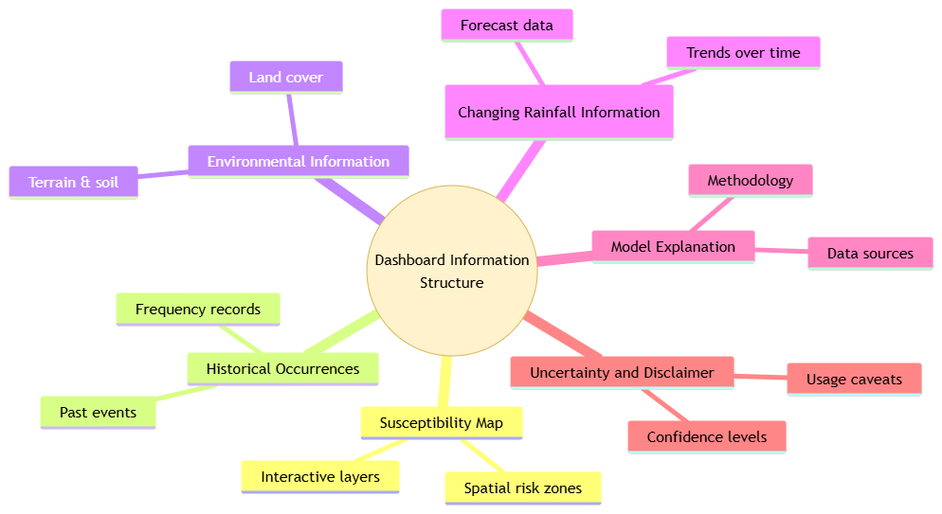
Figure 4 Proposed Information Components of a Landslide Susceptibility Decision-Support Dashboard
Landslide susceptibility information is commonly communicated through static maps, reports and technical tables. These formats can be used for documentation and planning but does not give many chances for users to examine specific areas, alter layers on the map or compare regions. Complex probabilities, model metrics and environmental variables could be challenging for non-technical users to understand. The combination of maps, filters, charts, indicators and explanatory text within one interface can be addressed for this communication limitation by interactive dashboards. Disaster-management dashboard research indicates that information should be presented based on user needs and not presented all at once regardless of the purpose of presentation (AlAbdulaali et al., 2022).
The example of WebGIS application shows how the spatial analysis can be tied with visualisation. Tengtrairat et al. (2021) integrated environmental variables, precipitation data and machine learning results into the WebGIS application of the Chiang Rai region. Irawan et al. (2024) also created the workflow for the detection and visualisation of landslide areas in Pacet District using the WebGIS technology. These studies show that model outputs can be transferred from technical analysis into interactive spatial interfaces, although the terminology, scale and variables used in each application depend on its intended purpose.
Visualisation must clearly distinguish susceptibility, hazard and risk. Susceptibility identifies where landslides are relatively more likely based on environmental conditions. Hazard additionally considers the possible occurrence of landslides through time, while risk includes the exposure and vulnerability of people, buildings or infrastructure. Therefore, the principal output of the proposed project should be labelled as susceptibility because exposure and vulnerability are not directly modelled.
Existing systems offer different visualisation approaches. The Landslide Hazard Assessment for Situational Awareness integrates environmental information together with satellite-estimated rainfall to produce quasi-global landslide nowcasts (Stanley et al., 2021). This forecast extension supports short-term situational awareness via incorporates precipitation forecasts (Khan et al., 2022). However, global outputs may not capture detailed slope modification, road construction or local geological variation. The proposed project can adopt the principle of separating underlying susceptibility from changing rainfall conditions without claiming to reproduce operational nowcasting.
At the national scale, a platform called IdroGEO, which integrates landslide inventories, hazard maps, risk indicators, reports and downloadable information within an Italian WebGIS. It primarily disseminates the established information rather than generating machine-learning predictions, while it possesses all of the features of open access, institutional data, and various user support (Iadanza et al., 2021). An example of the application of this type of institutional landslide management approach in the Republic of Korea shows how susceptibility mapping, monitoring and communication with the public (Eu et al., 2025). Such operational systems require maintained data, validated procedures and government authority that are outside the scope of a student prototype.
Susceptibility probabilities may be converted into categories such as low, moderate and high to simplify interpretation. However, categories may create a false impression of certainty if classification thresholds are not explained. A low-susceptibility class does not indicate permanent safety, while a high class does not prove that failure is imminent. The interface should therefore allow users to view probabilities, classification methods and support environmental information where appropriate.
A semi-dynamic dashboard may display relatively stable susceptibility information together with more frequently updated triggering-condition data. These components should remain visually distinct. A location may have high underlying susceptibility but limited recent rainfall, while another may experience substantial rainfall on less susceptible terrain. Separating the layers reduces the risk of combining different concepts into one unclear “risk score”.
Uncertainty communication is also important. Landslide susceptibility outputs may be affected by inventory incompleteness, pseudo-absence selection, spatial resolution, temporal mismatch and model generalisation. Schlögl et al. (2025) demonstrated that susceptibility and prediction uncertainty can be presented at the same time instead of presenting completely certain results of modeling. Interpretation of the machine learning models suggested that model uncertainty and the contributions of particular variables need to be communicated for more responsible interpretations (Le et al., 2024).
Therefore, the proposed dashboard should include clear legends, state or regional filters, historical occurrence layers, susceptibility probabilities or categories, summaries of environmental, source attribution and limitations, raising awareness about susceptibility and preliminary planning for Malaysia. It will not replace official government advisories, evacuation decisions or geotechnical investigations. It can aid to safer communities under Sustainable Development Goal 11, through the visualization of uncertainty in spatial information.

Similar Systems

Landslide Hazard Assessment for Situational Awareness Version 2
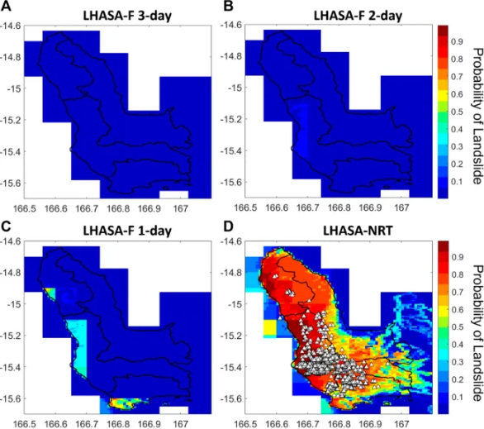
Figure 5 Comparison of Three-Day, Two-Day and One-Day LHASA Forecasts with Near-Real-Time Landslide Probability Estimates in Vanuatu (Khan et al., 2022)
The Landslide Hazard Assessment for Situational Awareness Version 2, referred to as LHASA Version 2, is a quasi-global system which was established with the aim of providing near real time data concerning rainfall-induced landslide hazards. This system uses machine learning to provide probabilistic landslide hazard ratings for one square kilometres grid cells between 60° north and 60° south latitudes (Stanley et al., 2021). The system was later extended in order to account for rainfall forecasts for short-term global landslide prediction (Khan et al., 2022).
LHASA integrates rapidly updated environmental information with relatively stable variables that are related to susceptibility. Dynamic variables of the system are represented by satellite-derived rainfall, soil moisture and information related to snow, while static factors are represented by slope, geology, fault zone, roads, and forest loss (Stanley et al., 2021). This allows the system to not treat rainfall as the only cause of landslide occurrence, while it enables to evaluate changing rainfall conditions within the context in relation to the environmental characteristics.
A major strength of LHASA is its broad geographic coverage. Satellite observations allow the model to provide situational information in regions where rain-gauge or ground-monitoring networks are limited. Its public map and downloadable outputs also make the information accessible to researchers, disaster organisations and humanitarian stakeholders. The model demonstrates how machine learning can combine dynamic triggering information with susceptibility-related environmental conditions at a large scale.
However, the system’s global scope limits its suitability for detailed planning. Its approximately one-kilometre resolution may not represent narrow road cuttings, small drainage channels, local slope modification or detailed geological variations. The model also estimates hazard or nowcasts conditions rather than producing only long-term susceptibility. Therefore, LHASA cannot be copied directly for the proposed project. Its main relevance is the principle of presenting underlying susceptibility separately from changing rainfall-related conditions. The proposed dashboard will apply this idea at the Malaysia-wide scale but will not claim to provide operational nowcasts or official warnings.

Machine Learning-Based Rainfall-Induced Landslide Susceptibility and Short-Term Early Warning Assessment in South Korea
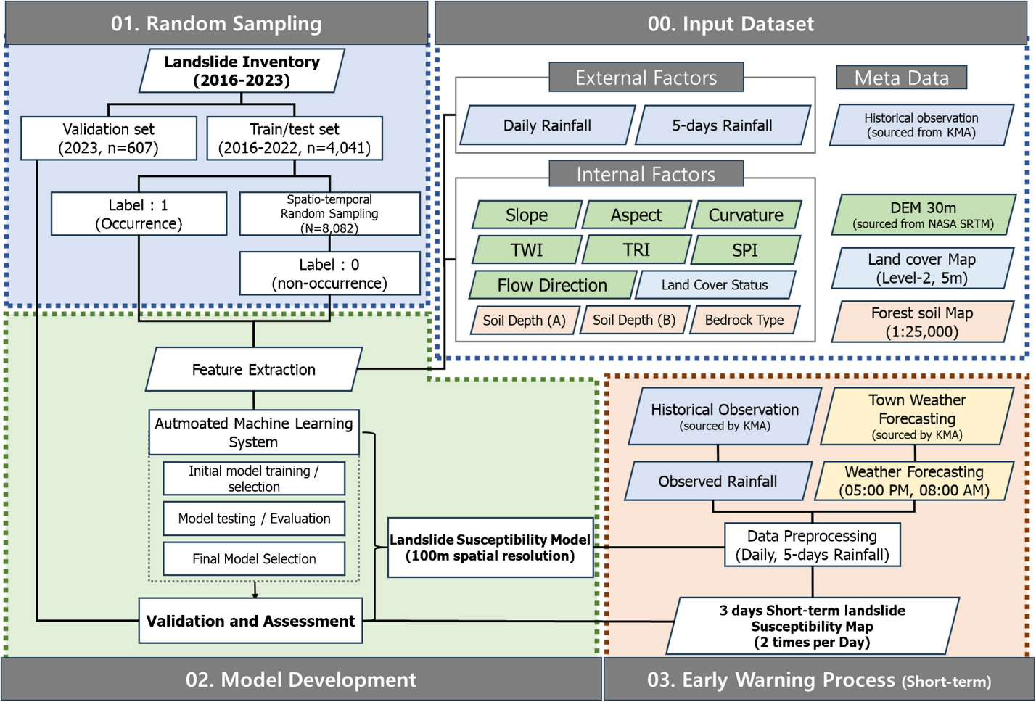
Figure 6 South Korean Landslide Susceptibility and Early Warning Workflow (Lee et al., 2025)
A nationwide rainfall-induced landslide susceptibility and short-term warning approach was developed for South Korea. The study combined meteorological, topographic and environmental variables to produce landslide susceptibility maps at a spatial resolution of 100 metres (Lee et al., 2025). Short-term weather forecasts were incorporated to update susceptibility estimates twice daily and provide information up to 72 hours in advance (Lee et al., 2025).

14 algorithms were compared with an automated machine learning process in this study. The best-performing model, Random Forest, was selected and subsequently optimised through hyperparameter tuning (Lee et al., 2025). Landslide-occurrence and non-occurrence samples from 2016 to 2022 were used to train the model, while stratified cross-validation and a separate test subset were used during model development (Lee et al., 2025).
An accuracy of approximately 0.93 and an Area Under the Receiver Operating Characteristic Curve of approximately 0.98 were achieved by the optimized Random Forest model (Lee et al., 2025). Moreover, the results of the confusion matrix show that approximately 93% of landslide occurrences and 94% of non-occurrence samples were correctly classified (Lee et al., 2025). More recent data from 2023 whereby 88% of 43 location-based events occurring in areas classified as high susceptibility of landslide events were used to further evaluate the model. At the administrative scale, 96% of 607 events occurred within areas classified as high hazard (Lee et al., 2025).
Nationwide susceptibility modelling, Random Forest, meteorological variables, later-event validation, and short-term forecast information were combined with the system, which made it highly relevant. However, the system’s operation highly depends on frequent data updates, national meteorological forecast as well as an established processing infrastructure. The reported forecast performance also varied according to the forecast issue time (Lee et al., 2025).
The system achieved strong classification performance and demonstrated that Random Forest could support nationwide rainfall-responsive susceptibility mapping. However, the performance of the short-term warnings was sensitive to the availability and the timing of the forecast rainfall. The reported accuracy was 76% for the 5:00 PM forecast but decreased to 41% for the 8:00 AM forecast. This is because during the morning, the forecast contained less complete rainfall information. Further calibration of the forecast data and incorporation of nowcasting to observe the rainfall was recommended by the authors to improve the system’s accuracy. The study also acknowledged that transferring the framework to other countries would require reliable weather forecasts, sufficient landslide inventories and region-specific adjustments of the conditioning factors (Lee et al., 2025).

Automated Landslide-Risk Prediction Using Web Geographic Information System and Machine Learning
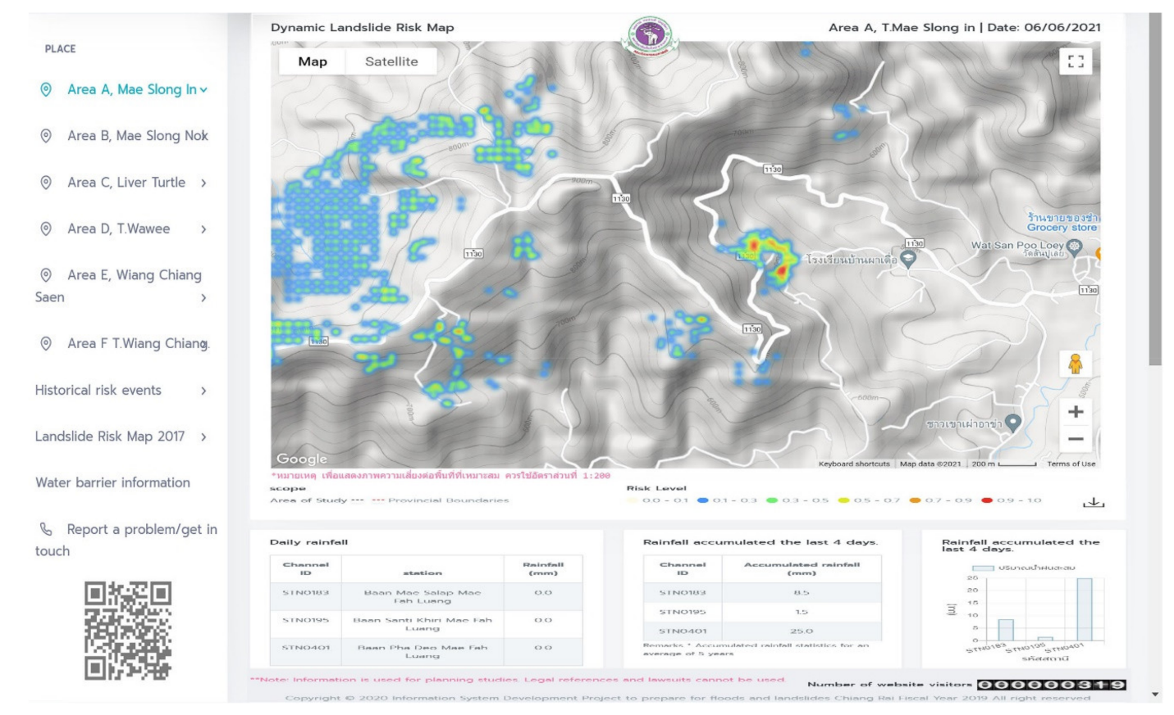
Figure 7 Automated WebGIS Interface for Landslide-Risk Prediction in Chiang Rai, Thailand (Tengtrairat et al., 2021)
The automated landslide-risk prediction system was developed as an integration of machine learning, Geographic Information System processing, precipitation information and WebGIS visualization for Chiang Rai Province, Thailand. This system employs such environmental parameters as altitude, slope, soil conditions, land cover and precipitation for assessing conditions associated with landslides. These results are then presented through a web geographic interface that helps to study the distribution of landslide risks spatially (Tengtrairat et al., 2021).
The Chiang Rai system is the most technically similar to the proposed project among the reviewed systems. Both employ preparation of geospatial parameters, machine learning modeling and presentation of the results through interactive maps. This system shows the ways on how relatively stable conditioning parameters such as terrain and land cover can be incorporated together with precipitation as a changing triggering factor (Tengtrairat et al., 2021).
Its main strength is the integration of analytical modelling and practical visualisation within one workflow. Instead of presenting predictions only through technical reports or static maps, the WebGIS interface makes the results more accessible to planners and disaster-management authorities. However, the model was developed specifically for Chiang Rai, where terrain, soil, rainfall, land cover and landslide characteristics differ from those in Malaysia. Therefore, its trained model and factor relationships cannot be transferred directly to a Malaysia-wide study.
The study also describes its output as landslide risk, although complete risk assessment normally requires exposure and vulnerability information. The proposed project should therefore describe similar outputs as landslide susceptibility. Overall, the Chiang Rai system provides a useful technical reference for integrating multiple environmental factors, machine learning and WebGIS visualisation. Nevertheless, the final predictor set, model and validation strategy must be adapted according to the availability and characteristics of Malaysian data.

Landslide Information System of the Republic of Korea
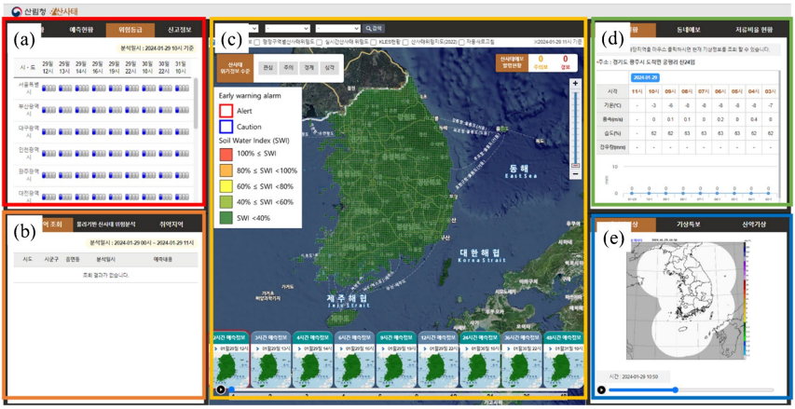
Figure 8 Main Interface of the Landslide Information System of the Republic of Korea (Eu et al., 2024)
The susceptibility mapping, rainfall monitoring, forecasting, and dissemination of information has been developed by a government-led framework for non-structural landslide mitigation, which is included in the system of the Republic of Korea. The government agencies such as the Korea Forest Service and the National Institute of Forest Science have developed the national approach, which provides a spatially integrated platform for communicating information related to landslides to national and local governments and the public (Eu et al., 2024).
The Korean approach integrates the dynamic meteorological information in the national landslide susceptibility or hazard maps, while the changing conditions of landslides are measured using rainfall measurements and soil water indices, not only that the spatial maps indicate areas that have higher environmental susceptibility to slope failure. This indicates that national landslide management does not only involve the development of a prediction model but also entails the ongoing process of collecting data, monitoring, institutional coordination, public communication and long-term system maintenance (Eu et al., 2024).
A major strength of the system is its national integration. Susceptibility information, rainfall-related monitoring and forecasting functions are organised within a government-supported framework. This allows relevant agencies to share information and apply more consistent procedures across administrative regions. However, its operational functions depend on maintained monitoring infrastructure, validated forecasting procedures and government authority.
These requirements distinguish the Korean system from the proposed academic dashboard. The proposed project will not have continuous ground monitoring, government-approved thresholds, evacuation procedures or emergency-response authority. Therefore, it should not attempt to reproduce the operational warning functions of the Korean system.
Nevertheless, the Landslide Information System provides a useful national reference for the proposed Malaysia-wide dashboard. It demonstrates how susceptibility information and changing environmental conditions can be presented within one spatial interface. It also highlights the need to separate academic decision-support outputs from official warning services. The proposed dashboard will support awareness and preliminary planning rather than government-authorised forecasting or emergency decisions.

Comparison of System Features
The geographic coverage, analytical methods, data inputs and operational purposes are different in the reviewed systems and the comparison of their main functions, machine-learning approaches, limitations and relevance to the proposed Malaysia-wide landslide susceptibility dashboard are also shown in Table 5. The limitations stated in the table correspond directly to the weaknesses identified in Sections 2.3.1 to 2.3.4.
Table 5 Comparative Analysis of Existing Landslide Information and Decision-Support Systems
System | Scope and main functions | Machine-learning method | Evaluation Metrics | Main gap | Relevance to proposed system
LHASA Version 2 (Stanley et al., 2021) | It combines satellite rainfall and soil moisture with terrain, geology, faults, roads and forest-loss information on quasi-global rainfall-triggered landslide nowcasts (Stanley et al., 2021; Khan et al., 2022). | Uses XGBoost from static and dynamic predictors to estimate the occurrence of probability of rainfall-triggered landslides. | - True Positive Rate  - False Positive Rate  - Mean prediction probability  - Combined validation TPR for LHASA Version 2: 93%  - Combined validation TPR for LHASA Version 1: 45%  - Combined validation mean prediction: 50%  - Validation records: 3,555 landslides  - Probability threshold: 0.12 | Its approximately 30-arcsecond resolution may not represent detailed Malaysian slopes, roads, waterways and local terrain modification. | Supports the separation of stable susceptibility conditions from changing rainfall information.
South Korea Machine Learning-Based Rainfall-Induced Landslide Susceptibility and Short-Term Warning Assessment (Lee et al., 2025) | Produces nationwide 100-metre susceptibility maps and integrates short-term meteorological forecasts to provide information up to 72 hours in advance. | Compared 14 algorithms through AutoML. Random Forest was selected and optimised as the final model. | - Accuracy: approximately 0.93  - ROC-AUC: approximately 0.98  - Correctly classified landslide samples: approximately 93%  - Correctly classified non-occurrences: approximately 94%  - 88% of 43 later location-based events occurred in high-susceptibility areas.  - 96% of 607 administrative events occurred in high-hazard areas | Forecast performance was sensitive to the timing and availability of rainfall data. Accuracy reached 76% for the 5:00 PM forecast but decreased to 41% for the 8:00 AM forecast, indicating that further calibration of forecast rainfall is required | The proposed system adopts Random Forest and rainfall-responsive susceptibility modelling but will evaluate several accumulated rainfall periods and clearly communicate uncertainty associated with rainfall inputs and update timing.
Chiang Rai WebGIS and Machine-Learning System (Tengtrairat et al., 2021) | Integrates elevation, slope, soil, land cover and precipitation to forecast regional landslides and visualize using WebGIS in Chiang Rai, Thailand. | Evaluated Linear Regression, Artificial Neural Network, LSTM and Bi-LSTM models. A hybrid Bi-LSTM with Random Forest model showed the best reported performance. | - Positive prediction rate.  - Negative prediction rate.  - Total accuracy.  - ROC-AUC.  - Long Short-Term Memory positive prediction rate: 0.92.  - Gated Recurrent Unit positive prediction rate: 0.83.  - Bidirectional Long Short-Term Memory positive prediction rate: 0.83 | The model was developed for selected locations in Chiang Rai and may not generalise to Malaysian environmental conditions directly. | Demonstrates the integration of geospatial factors, rainfall, machine learning and interactive maps.
Republic of Korea Landslide Information System (Eu et al., 2024) | National susceptibility information, rainfall monitoring, soil-water indicators, forecasting and public information dissemination combined. | The reviewed system operates as a wider institutional monitoring framework and is not based on one clearly identified machine learning algorithm. | - Nowcast HR: 92.87%  - Nowcast FAR: 84.34%  - One-hour forecast HR: 66.02%  - One-hour forecast FAR: 85.68%  - LSM HR, 2012–2013: 76%  - LSM HR, 2020–2022: 56.84% | Its warning capabilities of the system involve the use of official monitoring infrastructure, validated thresholds, institutional coordination and government authority. | Demonstrates national integration while reinforcing the distinction between decision support and official warnings.

The comparison reveals that all of the four systems have appropriate evidence, but none fully corresponds to the proposed project. LHASA Version 2 represents the integration of stable environmental parameters and changing rainfall parameters at a quasi-global scale, but its spatial resolution prevents the full presentation of Malaysian topography (Stanley et al., 2021). The South Korean machine-learning approach illustrates nationwide application of the Random Forest model, high predictive performance and the integration of short-term forecast, but it depends on national meteorological and operational infrastructure (Lee et al., 2025). The Chiang Rai system represents the integration of environmental variables, rainfall variables, machine learning techniques, and WebGIS visualization, but the model was constructed for some chosen places in Thailand and thus is not applicable in Malaysia (Tengtrairat et al., 2021). The Republic of Korea Landslide Information System illustrates national susceptibility mapping and operational warning system, but its high false alarm ratio and need for official infrastructure limit its suitability for direct replication (Eu et al., 2024).
The identified gap is the lack of an academic system in Malaysia which combines open historical landslide data, satellite rainfall data, terrain, land cover, roads, and waterways proximity into a machine learning and interactive dashboard environment. The proposed system addresses this gap through the application of Logistic Regression and Random Forest models on Malaysian data sets while taking into account spatial validation and separating the evaluation of susceptibility from the variations in rainfall. t is a contribution towards achieving SDG 11 by ensuring that landslide susceptibility data are accessible for awareness purposes and preliminary planning. However, it remains a prototype decision-support system and will not issue official warnings, evacuation instructions or professional geotechnical assessments.

Technical Research

Hardware and Software Identification and Justification
The project is expected to process tabular, vector and raster geospatial datasets covering Malaysia. The actual computational demand will depend on the final landslide inventory, raster resolution, number of candidate factors and modelling strategy. Although specialised high-performance infrastructure is not initially required, sufficient memory and storage are necessary because nationwide raster and vector operations may be computationally intensive.
Table 6 Recommended Hardware Requirements for the Proposed Dashboard
Component | Recommended specification | Justification
Processor | Modern 64-bit multi-core processor, equivalent to Intel Core i5 or above | Supports geospatial preprocessing, feature extraction, model training and dashboard execution
Memory | Minimum 8 GB; 16 GB recommended | Raster processing, spatial joins and model training may require substantial memory
Storage | At least 256 GB solid-state storage with sufficient free space | Stores original datasets, processed layers, notebooks, model artefacts and dashboard files
Graphics | Integrated graphics are sufficient | The planned tabular machine-learning models do not require dedicated graphics-processing hardware
Internet connection | Required during data acquisition, package installation and possible deployment | Supports authorised data retrieval, documentation access and web-based dashboard deployment
Display | Standard high-definition display | Supports GIS map inspection, dashboard design and visualisation testing
The recommended specifications exceed the minimum requirements of Windows 11 because GIS and machine-learning workloads require more resources than basic operating-system use. Microsoft lists 4 GB of memory and 64 GB of storage as Windows 11 minimums, but these values are insufficient for comfortable national geospatial analysis.
Table 7 Main Software Requirements and Their Intended Uses
Software | Proposed use | Justification
Python | Data preprocessing, geospatial analysis, machine learning and dashboard integration | Provides a broad scientific, machine-learning and geospatial ecosystem (Fleischmann et al., 2026)
QGIS | Spatial inspection, layer preparation, coordinate checking and map validation | Supports vector, raster and spatial-database formats through an open-source desktop GIS (Graser et al., 2025)
Visual Studio Code | Main code-development environment | Provides Python editing, debugging, environment management and source-control support (Visual Studio Code, 2026a)
Jupyter Notebook | Exploratory data analysis and model experimentation | Combines executable code, explanations, tables and visualisations in reproducible notebooks (Nebius, 2025)
Streamlit | Interactive dashboard development | Enables Python-based data applications without requiring extensive separate front-end development (Mhadhbi, 2026)
Google Earth Engine | Optional large-scale remote-sensing processing | May support image collection, clipping and extraction of environmental variables required by the final data sources (Google Earth Engine, 2023)
Python is selected because the project requires one environment capable of handling tabular analysis, geospatial processing, model development and dashboard implementation. The current official documentation of Python provides a maintained language reference and extensive standard library support (Dwivedi & Jaiswal, 2021). Python has also been extensively applied with GIS and machine learning methods in landslide susceptibility studies (Lu et al., 2024; Tengtrairat et al., 2021).

Integrated Development Environment (IDE) Chosen
Visual Studio Code would be applied as the primary Integrated Development Environment whereas Jupyter Notebook would help with exploratory data analysis (Nebius, 2025). This combination separates experimental analysis from the structured development of reusable scripts and the final dashboard.
Visual Studio Code supports Python interpreters, virtual environments, debugging, testing, terminal access and source control through its Python extension (Visual Studio Code, 2026b). Its Jupyter extension also allows notebook files to be viewed, executed and debugged within the same environment (Visual Studio Code, 2026c). These functions are useful because the project will progress from exploratory notebooks to organised preprocessing modules, saved models and dashboard scripts.
Jupyter Notebook is suitable for the Data Understanding, Data Preparation, Modelling and Evaluation phases of CRISP-DM. A notebook can combine executable code with written explanations, maps, charts and tables, making it suitable for documenting exploratory findings and reproducing modelling experiments. However, the final workflow should not remain entirely in one notebook because long notebooks may become difficult to test and maintain.

Libraries and Tools Chosen
The proposed system relies on several open-source Python libraries and tools, each selected for its specific role in the project workflow.
Table 8 Proposed Libraries and Tools for Data Processing, Modelling and Visualisation
Library or tool | Purpose | Justification
Pandas | Tabular cleaning, joining and transformation | Supports structured inventory records and model-ready feature tables (Training the Street, 2025)
NumPy | Numerical array operations | Supports efficient calculations and transformations used in feature engineering (Coursera Staff, 2024)
GeoPandas | Vector geospatial data processing | Extends Pandas with geometry, spatial joins, projections and geospatial file support (Ari Lamstein, 2026)
Rasterio | Raster reading, writing, reprojection and extraction | Supports terrain, land-cover and other gridded environmental layers (Qiusheng Wu, 2025)
Shapely | Geometry operations | Supports points, lines, polygons, buffering, distance and spatial relationships (Shrivastava, 2026a)
PyProj | Coordinate-reference transformation | Supports conversion between geographic and projected coordinate systems (Shrivastava, 2026b)
Scikit-learn | Preprocessing, classification, validation and metrics | Supports baseline and non-linear models through a consistent workflow (Stifi, 2024)
Joblib | Model and pipeline persistence | Supports efficient persistence of models containing large NumPy arrays (Scikit-learn, 2026)
Matplotlib | Static exploratory visualisation | Suitable for distributions, diagnostic plots and report figures (Sagar, 2024)
Plotly | Interactive dashboard charts | Supports interactive model and environmental summaries (Plotly, 2023)
Folium | Interactive web maps | Supports markers, layers, choropleths and Leaflet-based map interaction (Suma et al., 2024)
Streamlit | Dashboard interface | Integrates Python data, model outputs, controls and charts into a web application (Suma Katabattuni, 2024)
QGIS | Independent visual checking and spatial preparation | Assists validation of processed vector and raster outputs (Huang et al., 2024)
Google Earth Engine | Optional remote-sensing processing | May support cloud-based environmental-data extraction where appropriate (Lydon, 2021)
Scikit-learn is the project of the fundamental machine learning library and apply the Random Forest classifier to predict the probability of a landslide. The Random Forest handles high-dimensional geospatial data effectively, is robust to noise and missing values and also produces feature importances to determine the impact of contribution of each conditioning factor, which shows that it is particularly suitable for this project (Basheer et al., 2025). Pandas and NumPy libraries are employed for essential preprocessing steps before model training, such as data loading, cleaning, transformation, and feature engineering. Folium and Plotly were chosen for the purpose of visualising the results since their outputs are interactive and can be easily integrated into the Streamlit dashboard, allowing users to explore risk maps and charts dynamically.

Database Management System Chosen
The project will use organised flat files and a GeoPackage instead of a server-based relational database during prototype development. Historical records may be stored in CSV or Excel format, while landslide points, roads, waterways and boundaries may be stored as GeoJSON, Shapefile or GeoPackage vector layers. Raster datasets such as elevation, terrain derivatives, land cover and rainfall surfaces may be stored as GeoTIFF files. The final model-ready dataset may be stored in CSV or Parquet format, while trained model pipelines can be saved using Joblib.
This approach is suitable in that it reduces on the database configuration and maintenance while ensuring that geospatial analysis will still be carried out. The use of GeoPackage works well since it allows for multiple vector layers and attribute tables all in one portable file. PostGIS could be considered as the future addition when the project is expanded to support multiple users, frequent updates or more complex spatial queries (Hou et al., 2026).

Operating System Chosen
Windows 11 will be used primarily on the operating system because it is available on the laptop of researcher and provides support for most of the key software needed in this project, including Python, Visual Studio Code, Jupyter Notebook, QGIS and Streamlit. These tools are also supported on other operating systems, but Windows provides an easy-to-manage development environment for development and testing.
A project-specific Python environment needs to be set up using Conda or another environment-management tool. This will make it easier to handle compiled geospatial dependencies like GDAL, GEOS, and PROJ that are necessary for libraries like GeoPandas, Rasterio and PyProj. GeoPandas advocates for the use of Conda-based installation as a pragmatic way for managing these dependencies (subMit, 2021).
Although Windows 11 requires only basic hardware resources, national geospatial processing requires more memory and storage than the operating-system minimum. Therefore, the selected development computer should preferably provide at least 16 GB of RAM and sufficient solid-state storage.

Web Server Chosen
A dedicated production web server is not required during the initial development stage. Streamlit provides a built-in development server that allows the dashboard to run locally for implementation, testing and demonstration. This is suitable for presenting susceptibility maps, model outputs, filters and supporting environmental information.
Streamlit Community Cloud can be used for online demos, as it makes it possible to deploy apps directly from a GitHub repository, without needing to configure servers manually (Streamlit, 2024). However, the choice would still be considered provisional, as there could be some limitations related to the free hosting of national geospatial datasets, and some datasets may have restrictions on public redistribution.
Before deployment, the project must assess application memory, storage requirements, loading time, data permissions and the protection of access credentials. Restricted datasets or private keys should not be stored in a public repository. If online deployment is unsuitable, the dashboard can remain a locally demonstrated prototype.

Summary
This chapter reviewed the domain knowledge, similar systems and technical requirements relevant to the development of a landslide susceptibility decision-support dashboard for Malaysia. The domain research established that landslide occurrence is influenced by interactions among terrain characteristics, geological and surface conditions, land-cover change, human disturbance and rainfall. It also clarified that the proposed project focuses on landslide susceptibility rather than complete hazard or risk estimation. Historical landslide inventories provide essential evidence for model development, although incomplete reporting, uneven spatial coverage, temporal gaps and coordinate uncertainty may affect model reliability and national generalisation.
The review further demonstrated that Geographic Information Systems, remote sensing and machine learning are suitable for integrating heterogeneous landslide, rainfall and environmental datasets. Logistic Regression was identified as an interpretable baseline, while Random Forest and potentially XGBoost provide suitable alternatives for modelling nonlinear relationships. The assessment of existing systems showed that current platforms provide valuable mapping, monitoring and visualisation functions but may have limitations involving static outputs, local interpretability, Malaysia-specific data integration and the combined presentation of susceptibility and recent rainfall conditions.
The technical investigation supported the use of Python, Jupyter Notebook, Visual Studio Code, Pandas, GeoPandas, Scikit-learn, Google Earth Engine and related geospatial technologies. Overall, the findings provide the conceptual, analytical and technological foundation for the data collection, understanding and preprocessing procedures presented in Chapter 3.

CHAPTER 3: METHODOLOGY

Introduction
This chapter presents the methodology adopted to transform the proposed landslide susceptibility decision-support concept into a structured and implementable data analytics workflow. The Cross-Industry Standard Process for Data Mining, or CRISP-DM, is used to organise the project because it supports iterative activities involving data understanding, preparation, modelling, evaluation and deployment. The chapter first explains the methodology and justifies its suitability for a machine-learning and geospatial analytics project. It then describes the collection of historical landslides, rainfall, terrain, land-cover, road, waterway and boundary data from multiple open sources. The data-understanding stage examines the structure, temporal coverage, quality, event characteristics and spatial distribution of the Malaysia inventory and additional candidate inventories from neighbouring countries. This is followed by initial data preprocessing, which includes record selection, duplicate review, missing and invalid data handling, schema standardisation and preparation for environmental-feature extraction. These procedures are designed to support the subsequent construction and evaluation of a Malaysia-focused landslide susceptibility model and decision-support dashboard.

System Development Methodology

Introduction of CRISP-DM Methodology
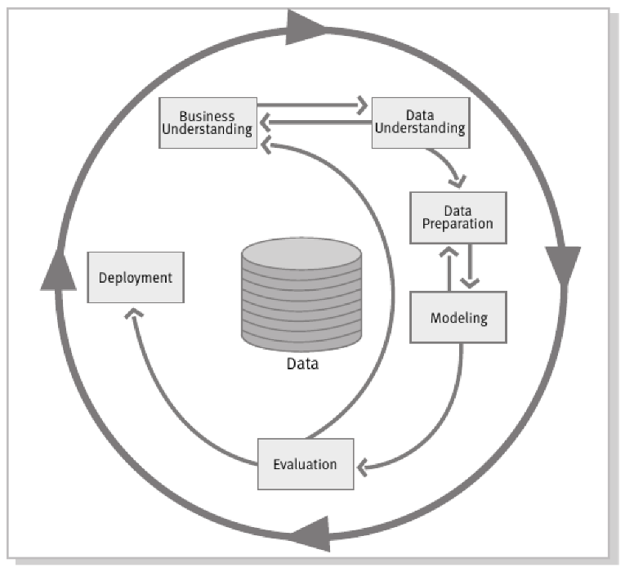
Figure 9 The Structure of CRISP-DM
The Cross-Industry Standard Process for Data Mining, also referred to as CRISP-DM, is a methodology aimed at the management of data mining and data science projects. Business Understanding, Data Understanding, Data Preparation, Modelling, Evaluation and Deployment are the six interrelated stages in the process that involve structuring the project. The aforementioned stages are designed to provide guidelines to the whole project from defining the problem to delivering the analytical solution.
Although the six stages have been ordered in a logical manner, CRISP-DM is not a linear method. The project might return to an earlier phase when new findings or limitations are identified. For example, an issue with model effectiveness could prompt the revision of the preparation process, whereas problems that become apparent when deploying the model would necessitate a modification to the model outputs or system requirements. It is through such an iterative process that CRISP-DM can facilitate experimentation in data science projects (Shimaoka et al., 2024).
Its original phases can be maintained while new practices have been included to cover contemporary needs in the field of data science, which showing that CRISP-DM has been relevant. The latest modifications have introduced practices that are related to project management, cooperation, deployment, and models’ maintenance while keeping the core of the data-mining lifecycle. Thus, the methodology ensures stability while being flexible enough to cover the projects when the data, analytics used and expected outputs change throughout the development process the methodology ensures stability while being flexible enough to cover the projects when the data, analytics used and expected outputs change throughout the process (Shimaoka et al., 2024).
The methodology is appropriate for conducting the analysis of landslide susceptibility as the project requires more than just training of the machine learning model. It involves problem definition, knowledge of spatial information, sampling for modelling, creation of environmental features, prediction verification and the communication of the results through an operational system. Recent landslide research has similarly used modular workflows covering activities from conceptualization and input preparation up to Random Forest modelling and production of a susceptibility map (Edrich et al., 2024).
CRISP-DM will be used to develop a semi-dynamic decision-support dashboard for predicting landslide susceptibility and rainfall in this project. This will form the overall structure which the investigation of the problem will be conducted to generate the susceptibility model and its validation and to present the output susceptibility and warning information through an interactive dashboard.

Methodology Choice and Justification
The CRISP-DM approach is chosen to be used as the main methodology since the proposed project includes the cyclical process of problem identification, data analysis, modeling, and evaluation and deployment of the system (Shimaoka et al., 2024). Such an approach is suitable for the modeling of landslides susceptibility as it requires a reliable analytical process rather than interface development (Edrich et al., 2024).
Several of methods were analyzed before making the selection. KDD is oriented towards discovery and interpretation of knowledge, while sampling, exploration, modifications, modelling, and assessment is oriented by SEMMA, CRISP-DM covers the entire lifecycle since it establishes connections such as problem understanding, data preparation, modelling, evaluation and deployment between the stages (Shimaoka et al., 2024).

Table 9 Comparison of CRISP-DM, KDD, SEMMA and Waterfall
Criterion | CRISP-DM (IBM, n.d.) | KDD (Shimaoka et al., 2024) | SEMMA (SAS, 2025)
Main focus | Complete data-science project lifecycle | Knowledge discovery from data | Analytical and modelling activities
Main phases | Business Understanding, Data Understanding, Data Preparation, Modelling, Evaluation and Deployment | Selection, Pre-processing, Transformation, Data Mining and Interpretation | Sample, Explore, Modify, Model and Assess
Problem understanding | Business Understanding as a dedicated first phase included | Domain and project objectives are considered during the knowledge-discovery process | Begins with data sampling without including a separate problem-understanding phase
Data preparation | Dedicated Data Preparation phase before modelling | Covered through pre-processing and transformation | Covered through Sample and Modify stages
Model development and evaluation | Separate Modelling and Evaluation phases | Data mining followed by interpretation | Model and Assess phases
Deployment | Deployment is included as the final named phase | Not clearly defined as a separate phase | Not included as a dedicated phase
Iterative flexibility | High and phases may be revisited | Activities may be repeated when discovered patterns require further selection, preprocessing or transformation | Analytical activities can be repeated during sampling, modification, modelling and assessment
Suitability for this project | High | Moderate | Moderate

Table 9 is clear that CRISP-DM has the most comprehensive structure among all frameworks for the project suggested. As opposed to KDD and SEMMA, it has clearly defined stages for problem understanding and deployment of the results of the analysis. CRISP-DM is more adaptive since it can lead back to the stage of data preparation or modeling based on the findings of model evaluation, which also compares to Waterfall. This would be ideal for conducting research on landslide susceptibility where the quality of the inputs prepared, models built and validation would influence the quality of the output generated in terms of the landslide susceptibility map. Workflows have been applied for combining various environmental factors, machine learning and warnings in landslide studies (Kang et al., 2024).
Table 10 Alignment Between Project Objectives and CRISP-DM Phases
Project objective | Relevant CRISP-DM phases
To identify the characteristics of rainfall, topography, land cover, location and history of landslides that affect the risk of landslides in Malaysia. | Business Understanding and Data Understanding
To analyse the connections between geospatial attributes, rainfall accumulation and historical landslides through data analytics and Geographic Information System techniques. | Data Understanding and Data Preparation
To evaluate machine-learning techniques for classifying landslide susceptibility in Malaysia. | Data Preparation, Modelling and Evaluation
To design an interactive dashboard for displaying susceptibility, rainfall and warning indications generated by the model. | Evaluation and Deployment
Each project goal is covered by certain CRISP-DM stages, as shown in Table 10 The first objective is attained through the definition of the analytics requirements and the identification of the landslide factors. The second objective is achieved through analysis and preparation of the variables for spatial and statistical analysis. The third objective is accomplished by model preparation, training and evaluation, whereas the last goal is fulfilled through the transformation of validated results to an interactive dashboard. Such matching provides the traceability of the project objectives, methodologies and final deliverables. Deployment is crucial since the output of the landslide model needs to be translated into maps and decision-making tools instead of remaining only as the result of technical modelling (Edrich et al., 2024).
Therefore, CRISP-DM is chosen as the sole methodological approach to be applied in this research since it offers a structured and deployment-focused approach to the entire project lifecycle. It is appropriate for an individual CSDA project and does not require the formal roles, meetings and sprint structure associated with Scrum. The same six stages of the CRISP-DM approach will be employed in organising the project planning to ensure that all scheduled activities align with the phases of Business Understanding, Data Understanding, Data Preparation, Modelling, Evaluation, and Deployment, which are conducted within each phase are explained in the following subsection

Phases, Activities and Processes of CRISP-DM
- Business Understanding
The project problem, aim, objectives, scope, intended users and expected system outcomes are defined by the Business Understanding phase. The project seeks to enhance the value of existing static data on landslide susceptibility through the integration of environmental and rainfall change. However, the intended output is relative landslide susceptibility and modelling warning indicators rather than complete landslide risk, because exposure, vulnerability and expected loss are not modelled. Rainfall should be considered alongside terrain and environmental variables, indicating that a similar amount of rainfall may lead to a different response across different locations (Kang et al., 2024). The activities such as defining Malaysia-wide scope, identifying intended users, establishing project boundaries, confirming measurable objectives and determining the expected dashboard functions are included in this phase, which is the approved problem background, aim, objectives, scope and initial system requirements.
- Data Understanding
The Data Understanding phase explores the collected data to identify its characteristics, comprehensiveness, quality, and fitness for the analysis. The variables and observations will be analyzed by applying descriptive statistics, frequency distribution, maps, and other forms of exploratory visualization. Missing values, formatting inconsistencies, odd data, duplicated observations, as well as insufficient spatial or temporal coverage will be explored as well. Landslide observation data quality and completeness are crucial as a susceptibility model can learn only about landslides that are included in the training information. An incomplete and spatially limited landslide inventory could lead to insufficient representation of certain environmental conditions and affect the final susceptibility map (Lin et al., 2021; Tan et al., 2024). The activities performed in this phase include exploration of variable types, spatial reference analysis, exploration of distributions, and identification of limitations. An initial data quality report and a clear decision are the expected outputs on which information can move on to the next phase.
- Data Preparation
The collected data will be converted to a consistent and model-ready format in the Data Preparation phase. The activities include cleaning of data records, format correction, harmonizing spatial references, dealing with missing data, outlier checking, creation of a control sample, selecting appropriate variables and their integration into one analysis table. The recorded landslide points are taken to be positive cases, while the non-landslide points assumed to be the absence cases are prepared as pseudos because an unrecorded location cannot be taken as permanently stable. The selection of these controls must be performed cautiously since different non-landslide sampling approaches produce different outputs in terms of landslide susceptibility mapping. Model accuracy and spatial prediction were found by Dou et al. (2023) to depend on the technique used for sampling non-landslide cases. Continuous, categorical and circular variables will also be transformed appropriately. The target labels, prepared features and spatial grouping information for modelling and validation are contained in the expected output, which is a reproducible dataset.
- Modelling
The Modelling phase develops the classification algorithms that would be employed to estimate landslide susceptibility. Logistic Regression will be applied to act as a baseline, providing an interpretable reference that would be used to evaluate whether the prepared variables can differentiate between the landslide and pseudo-absence samples. Random Forest would be used as the primary model because it can represent the relationship between the non-linear and interacting environment variables. It has also proved to be able to create probability predictions and feature importance information that would interpret the model. Tree-based algorithms have been found to perform well in landslide susceptibility studies, including applications in Malaysian landslide-prone areas (Martin & Chai, 2022). Random Forest has also been included in the reproducible landslide-susceptibility workflow process that includes preparation, modelling and mapping of the landslide susceptibility (Edrich et al., 2024). The construction of preprocessing pipelines, training of the models, tuning suitable hyperparameters and saving the final model artefacts are the activities. The expected outputs are trained models, selected parameters and feature-contribution results.
- Evaluation
The Evaluation phase determines whether the developed models meet the objectives of the project and produce sufficiently reliable results for dashboard implementation. The performance of the model will be assessed using accuracy, balanced accuracy, precision, recall, F1-score, Receiver Operating Characteristic Area Under the Curve and confusion matrices. Accuracy will not be used independently since its value could depend on the ratio and distribution of positive and control samples. The importance of recall is associated with the evaluation of the number of correctly identified landslide cases, whereas precision demonstrates the reliability of positive classification. Validation will take into account spatial dependence in that case observations located near each other share similar conditions. This type of validation or spatially dependent validation, such as grouped or spatially aware validation will be implemented depending on the possibility offered by the sample distribution. Landslide studies have emphasised that evaluation should consider both predictive performance and the reliability of the resulting susceptibility map (Selamat et al., 2022b; Edrich et al., 2024). The output is a model-evaluation report and justification for the selected model.
- Deployment
The Deployment phase involves the presentation of the validated analytical results in the form of a decision-support dashboard. This user interface will be developed gradually, starting with the base map and susceptibility, followed by the addition of rainfall-driven indicators, filters, charts, model explanations and system limitations. The distinction between susceptibility, rainfall-driven conditions, and warning indicators will be made in the system to prevent users from confusing them. The system will also explain that its outputs are intended for awareness and preliminary decision support rather than official warnings, emergency-response decisions or professional geotechnical assessment. Research on global landslide nowcasting similarly distinguishes model-based situational information from complete operational warning procedures (Stanley et al., 2021). The activities consist of interface design, model integration, map generation, functionality testing, improvement, and documentation. The expected output is a functioning Malaysia-wide dashboard prototype.

Data Collection
The historical landslide observations and environmental geospatial data that cover Malaysia are required for the proposed study. These datasets have been divided into six main categories, such as historical landslide inventory, administrative boundaries, terrain, rainfall, land cover and proximity-related vector layers, remaining applicable even if the provider or specific dataset has changed.
The candidate open datasets are used to test the technical feasibility of loading, validating and producing Malaysia-wide geospatial information, which also requires the relevant Malaysian authority to provide the official historical inventory. Therefore, the final inventory provider, number of records, temporal coverage and available attributes will be updated after the official dataset has been received and assessed.

Table 11 Candidate Data Sources, Characteristics and Intended Uses
Data category | Candidate provider | Intended use | Coverage | Temporal characteristic
Historical landslide inventory | NASA Cooperative Open Online Landslide Repository, including the Global Landslide Catalog (NASA, 2025)  Malaysia, Thailand, Philippines, and Indonesia: https://gpm.nasa.gov/applications/landslides/coolr | Positive landslide observations and event attributes | Malaysia-wide, Thailand, Philippines and Indonesia | Historical
Administrative boundary | Natural Earth Admin 0 – Countries, 1:10 million scale (Natural Earth, n.d.)  Malaysia, Thailand, Philippines, and Indonesia: https://www.naturalearthdata.com/downloads/10m-cultural-vectors/10m-admin-0-countries/ | Clipping and location validation | Malaysia | Static
Terrain | NASA SRTM Digital Elevation 30 m through Google Earth Engine (Google Earth Engine, 2025b)  https://developers.google.com/earth-engine/datasets/catalog/USGS_SRTMGL1_003 | Elevation, slope and aspect derivation | Malaysia | Static
Rainfall | NASA GPM IMERG Release 07 through Google Earth Engine (Google Earth Engine, 2025a)  https://developers.google.com/earth-engine/datasets/catalog/NASA_GPM_L3_IMERG_V07 | Recent and antecedent rainfall variables | Malaysia | Dynamic
Land cover | Google Dynamic World V1 through Google Earth Engine (Googel Earth Engine, n.d.)  https://developers.google.com/earth-engine/datasets/catalog/GOOGLE_DYNAMICWORLD_V1 | Surface-condition classification | Malaysia | Periodically updated
Roads and Waterways | OpenStreetMap regional extract distributed by Geofabrik  Malaysia (Geofabrik, 2025):  https://download.geofabrik.de/asia/malaysia-singapore-brunei.html  Thailand (Geofabrik, 2026):  https://download.geofabrik.de/asia/thailand.html  Philippines (Geofabrik, 2025b):  https://download.geofabrik.de/asia/philippines.html  Indonesia (Geofabrik, 2025a):  https://download.geofabrik.de/asia/indonesia.html | Distance-to-road and Distance-to-waterway calculation | Malaysia | Periodically updated

Initial Data Understanding and Data Pre-processing

Data Understanding

Candidate Inventory Acquisition and Structure
The code configures project paths, output folders, required libraries and the five target countries. It generates the available inventory structure for each country in a concise summary format through retrieving or loading each COOLR inventory, identifies important fields such as event date, trigger, category and size, standardises date handling.
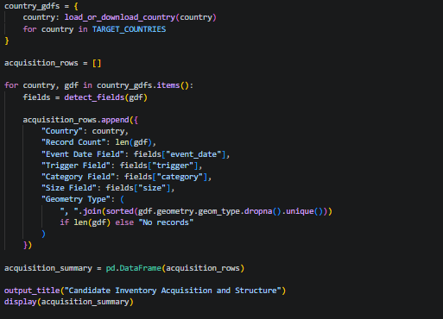
Figure 10 Source Code for Loading and Summarising Candidate Landslide Inventories
The output confirms that point geometries and consistent key fields were loaded successfully in all of the five candidate inventories. The Philippines contains the most records with 778, followed by Indonesia with 431, Malaysia with 236, Thailand with 94, while the Singapore has 1. Singapore therefore contributes almost no additional training data.
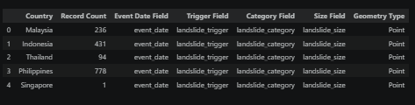
Figure 11 Candidate Landslide Inventory Structure and Record Count by Country

Malaysia-Only Baseline Understanding
The code summarises record and geometry quality with the selected Malaysia inventory, detects the event-date and administrative fields, and converts dates into a consistent format. It also groups valid records per year, generates an annual bar chart and counts records per administrative division for future geographic comparison.
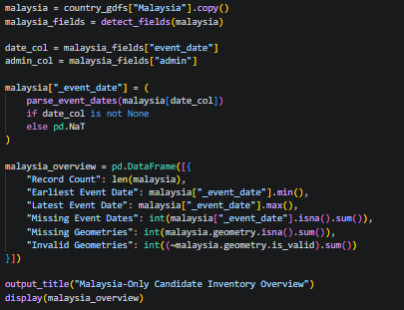 | 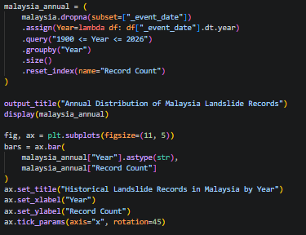
Figure 12 Source Code for Assessing the Malaysia Landslide Inventory
The Malaysia inventory contains 236 valid point records covering March 2007 to March 2022, without missing dates, missing geometries or invalid geometries. Annual records vary considerably, having at 35 events in 2017, followed by 33 in 2014. There is only one event recorded in 2022.

Figure 13 Overview and Quality Summary of the Malaysia-Only Landslide Inventory
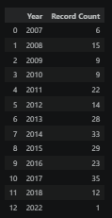 | 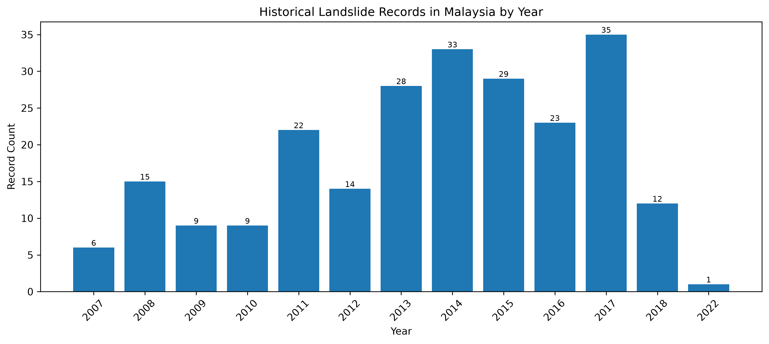
Figure 14 Historical Landslide Records in Malaysia by Year

Cross-Country Record and Temporal Comparison
The code converts the event-date column in the dataset of each country into a standard datetime format, calculates record count, temporal range, represented years and missing-date percentage, and generates country-level and annual comparison charts. The results are also saved as CSV files for later reporting and dataset-selection decisions.
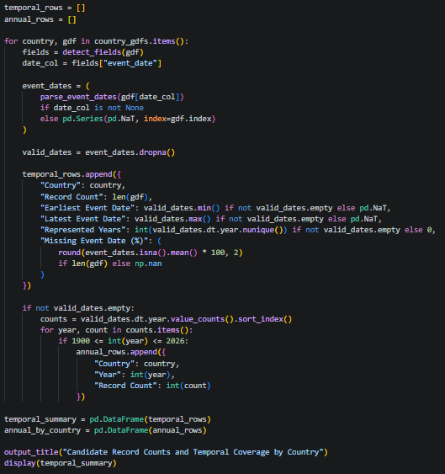
Figure 15 Source Code for Cross-Country Record and Temporal Comparison
The largest dataset comes from the Philippines with 778 records and the longest timeline covering from 1988 to 2019. Indonesia contributes 431 records, Malaysia 236, Thailand 94 and Singapore only one. All datasets have complete event dates, but their different periods and annual reporting patterns may affect cross-country comparability.

Figure 16 Candidate Landslide Record Counts and Temporal Coverage by Country
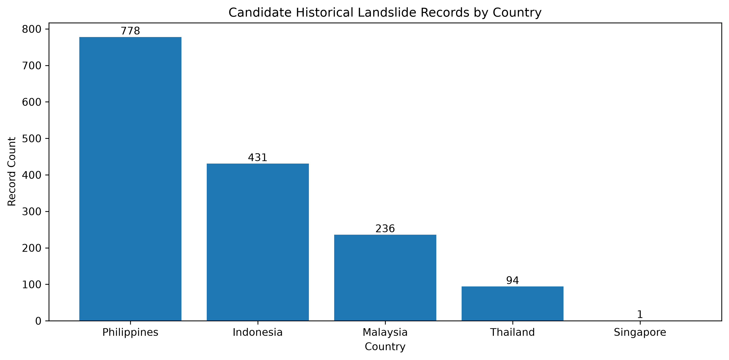 | 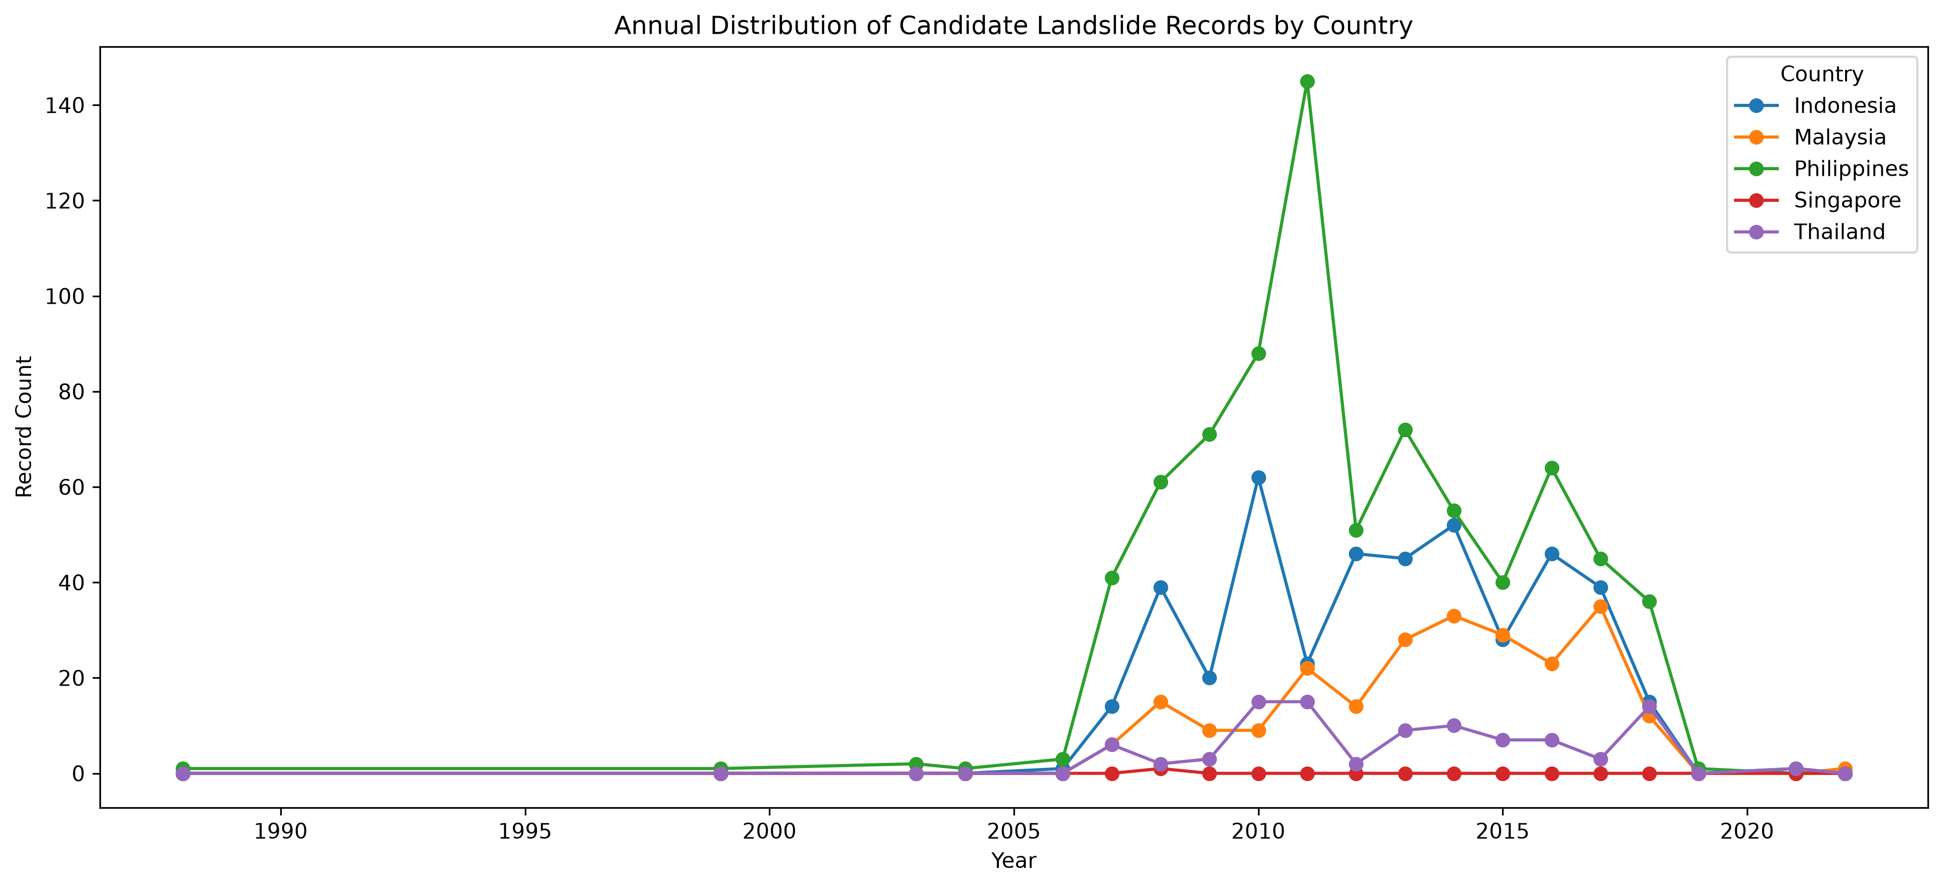
Figure 17 Cross-Country Comparison of Candidate Record Counts and Annual Landslide Distributions

Cross-Country Data Quality Assessment
The code evaluates missing dates, triggers, categories, sizes and geometries for each country. It also detects exact duplicates, repeated event identifiers and records sharing approximately the same coordinates with the same date of the event. Potential spatial-temporal duplicates are output separately for manual verification during Data Preprocessing.
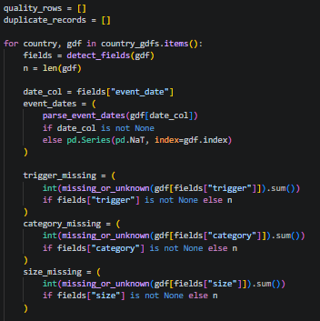 | 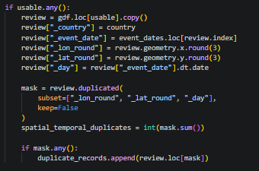
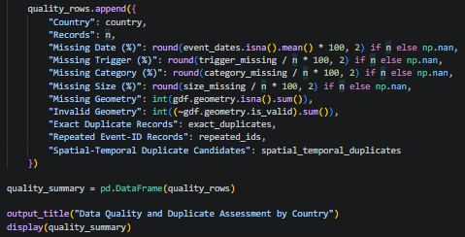
Figure 18 Source Code for Assessing Inventory Quality and Duplicate Candidates
Dates and geometries in all inventories are complete, while missing event attributes are still low with the exception of the single entry in the dataset from Singapore that lacks trigger information. Exact duplicates and duplicate event IDs were not found and nineteen spatial-temporal duplicate candidates were flagged and must be manually examined before removal.
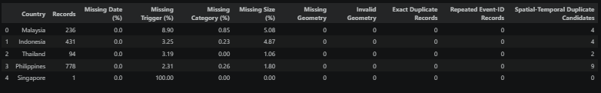
Figure 19 Cross-Country Data Quality and Potential Duplicate Assessment
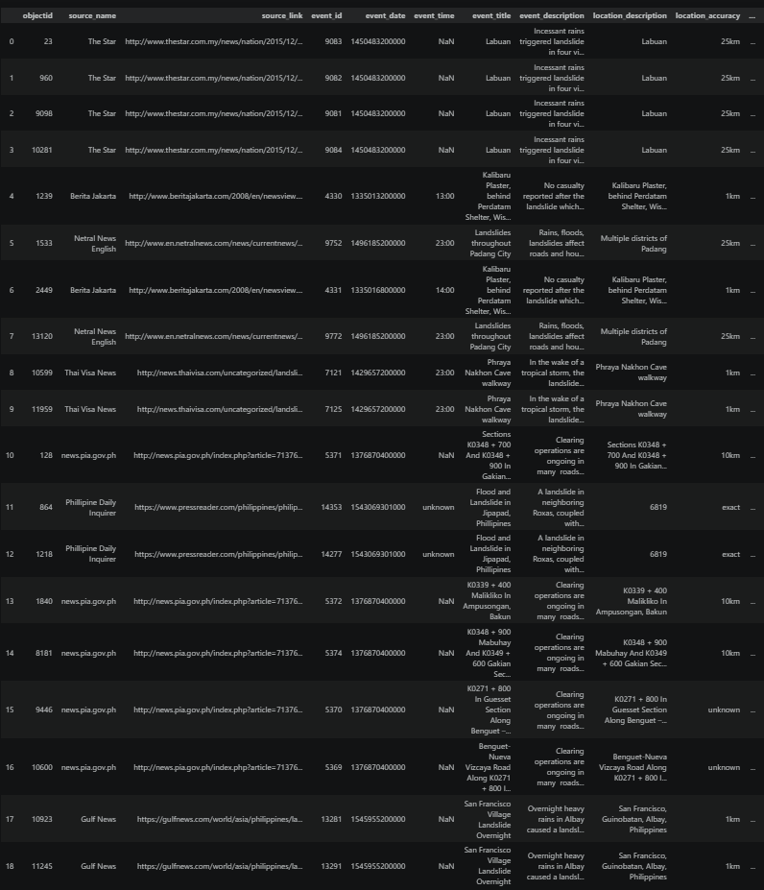
Figure 20 Potential Spatial-Temporal Duplicate Landslide Records for Manual Review

Event-Attribute Comparison
The code standardises missing text values, calculates the frequency and percentage of each trigger, landslide category and size, and identifies the dominant value for each country. Full distributions are saved as CSV files, whereas only the primary categories of each variable are visualised in the notebook.
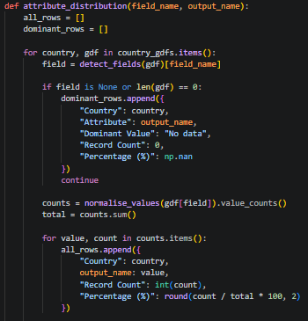
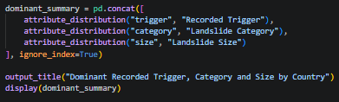
Figure 21 Source Code for Comparing Landslide Event Attributes
Downpour is the dominant recorded trigger in Malaysia, Indonesia, Thailand and the Philippines, while the sole landslide has an unknown trigger in Singapore. Landslide is the dominant category in the four larger inventories, and the most prevalent landslide size is medium. Singapore differs because it contains only one record of mudslide.
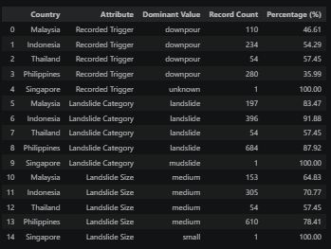
Figure 22 Dominant Recorded Trigger, Landslide Category and Event Size by Country

Cross-Country Spatial Distribution
The code removes missing, empty, and invalid geometries, combines valid landslide points of all the countries, and calculates unique rounded locations as an indicator of spatial concentration. It also overlays the records on Southeast Asian country boundaries and saves both the spatial summary and regional distribution map.
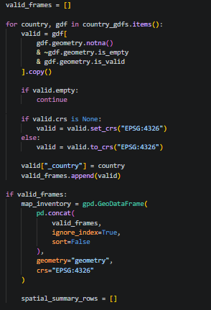
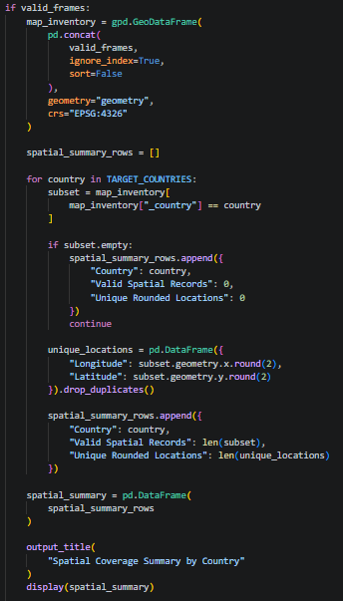 | 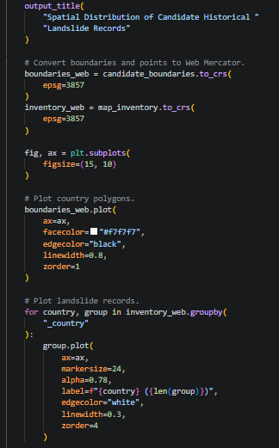
Figure 23 Source Code for Validating and Mapping Landslide Locations
Spatial geometries are valid for all 1,540 candidate records. Indonesia has 414 unique rounded locations out of 431 records, while the Philippines has 683 out of 778, which means that there are more repeated or nearby located events. The regional map shows that records distribution is uneven and concentrated in specific areas rather than uniformly covering each country.
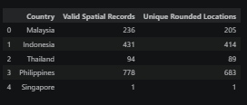
Figure 24 Valid Spatial Records and Unique Rounded Locations by Country
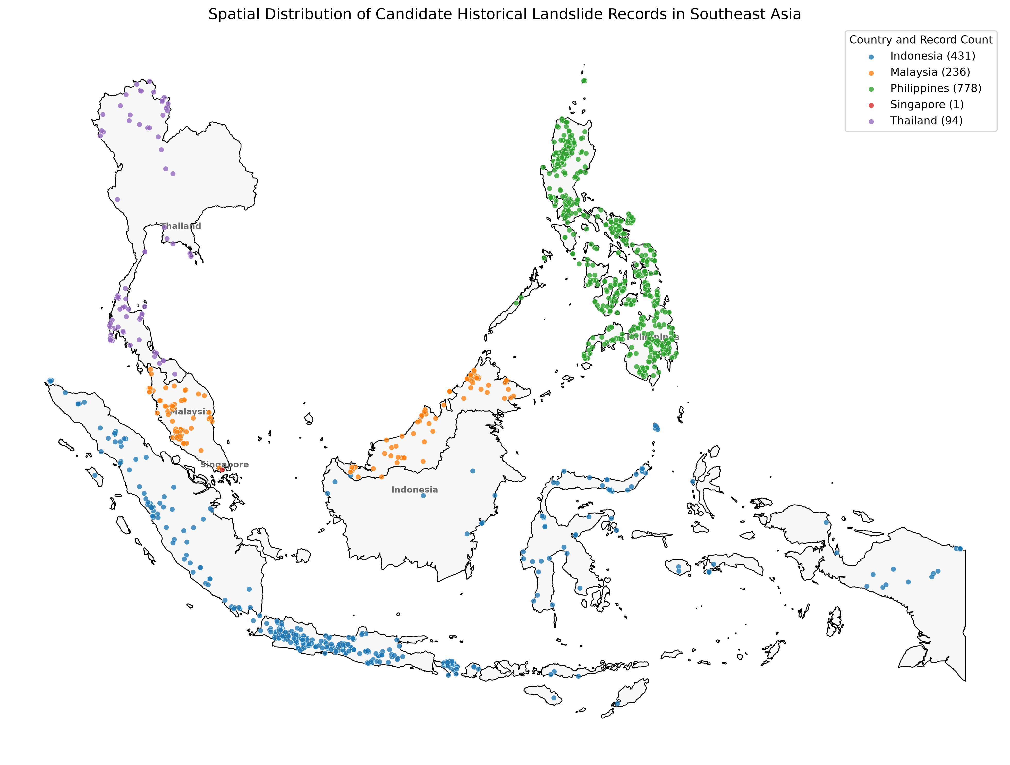
Figure 25 Spatial Distribution of Candidate Historical Landslide Records in Southeast Asia

Data Understanding Summary and Candidate Dataset Decision
The code integrates temporal coverage, data quality and duplicate records into one table on a country-level summary. Environmental comparability, major concerns and decisions about candidates will be added to this table after which it will be exported for final review. The merge of roads and waterways should be dropped since environmental availability is no longer part of Data Understanding.
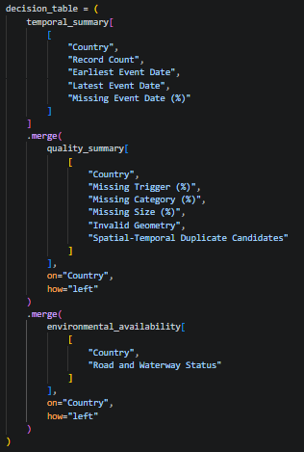
Figure 26 Source Code for Summarising Candidate Dataset Decisions
The table consolidates record quantity, temporal coverage, missing attributes, geometry validity and duplicate candidates for each country. Inventories are available from Malaysia, Indonesia, Thailand and the Philippines, while Singapore contributes only one record. Final inclusion decisions remain pending until environmental comparability and dataset concerns are evaluated.
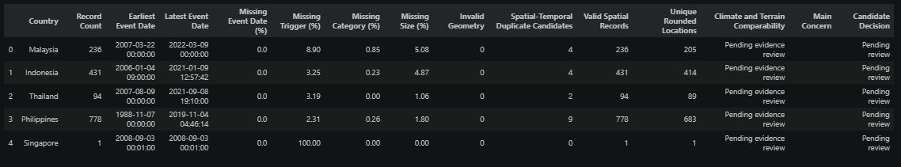
Figure 27 Data Understanding Summary and Candidate Country Selection Assessment

Data Pre-processing

Candidate Country and Record Selection
The code defines the candidate countries, country codes and selection status for each inventory. All the GeoJSON files are loaded, standardized CRS to EPSG:4326 and the original number of events is recorded. Then the summary table is created and stored to track the progress of the country selection procedure.
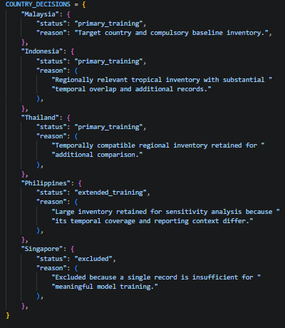 | 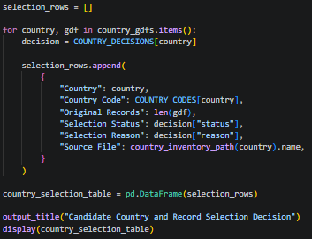
Figure 28 Candidate Country and Record Selection
The outputs indicate that Malaysia, Indonesia and Thailand were chosen as candidate countries for the first dataset, whereas the Philippines was kept for a prolonged sensitivity test, and Singapore wasn't chosen due to having only one record. Original numbers of the records were kept the same, which means that no landslide records were deleted during this country selection stage.
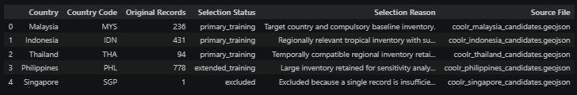
Figure 29 Candidate-country selection decisions and supporting justifications
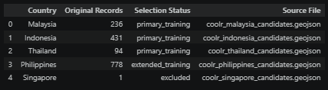
Figure 30 Original landslide inventory counts and selection status before preprocessing

Duplicate Record Review and Handling
The candidates for potential duplicates are determined by the code on the basis of matching event dates and coordinates rounded to three decimal places. Candidate records are assigned group identifiers and exported for further manual investigation. Any previous decision made during the review is preserved, while summary and detailed tables are generated without automatically removing any records.
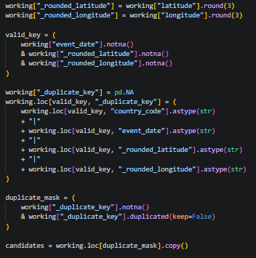 | 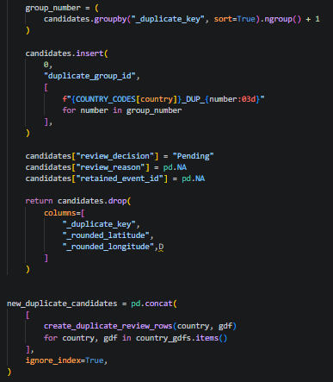
Figure 31 Source Code for Duplicate Candidate Review and Handling
It turned out that there are 19 potential duplicate records in eight groups in Malaysia, Indonesia, Thailand and the Philippines. They are all still pending manual review and haven't been deleted yet. Records sharing similar dates and locations may represent separate landslide events; therefore, descriptions, sources and event details must be compared before removal.
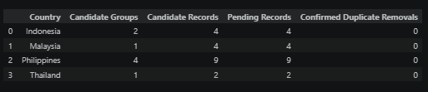
Figure 32 Duplicate Candidate Group Summary
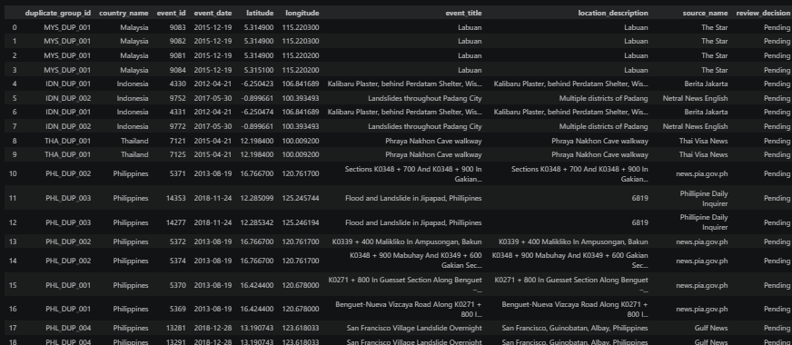
Figure 33 Duplicate Records for Manual Review

Missing and Invalid Record Handling
The code determines if a record has a valid event date, coordinates, and point geometry. A record is given a retain, remove, or repair label based on decision according to predefined rules. Removed records are documented in an audit log, while retained geometries are reconstructed from validated coordinates using EPSG:4326.
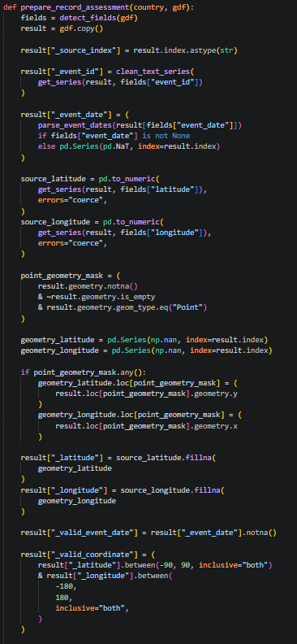 | 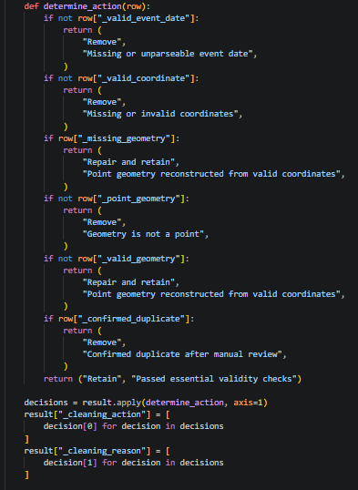
Figure 34 Source Code for Missing and Invalid Record Handling
The assessment did not find any missing dates, invalid coordinates, missing geometries or invalid point geometries in the five country inventories. There were no removed or repaired records, resulting in an empty removal log. Records with missing descriptive attributes were retained since they are not mandatory environmental predictors while duplicate candidates need further review.
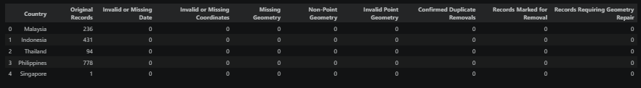
Figure 35 Essential Record Validity Assessment

Schema and Spatial Reference Standardisation
The code standardizes each country inventory after cleaning to have a uniform 17-field data structure. It standardises dates, coordinates, country identifiers and descriptive attributes, assigns positive-event labels and generates stable sample identifiers. All records are stored as point geometries in EPSG:4326 while retaining original event and source references for traceability.
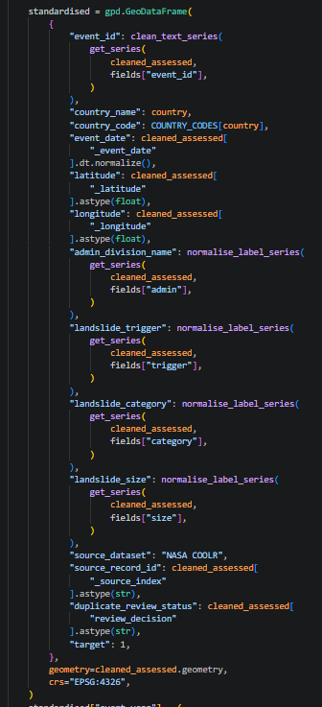 | 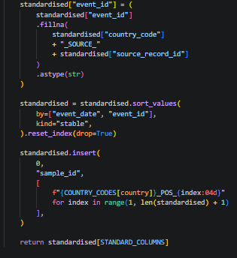
Figure 36 Source Code for Inventory Schema and CRS Standardisation
The results demonstrate that the inventories have been successfully transformed into a common schema, with correct data types and field descriptions. The Malaysia sample contains properly structured identifiers, dates, coordinates, attributes and points. Every saved landslide is tagged as a positive event, with target=1.
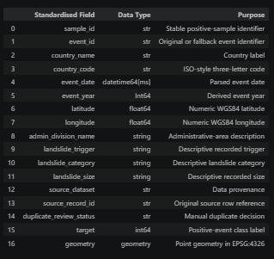
Figure 37 Standardised Inventory Field Structure
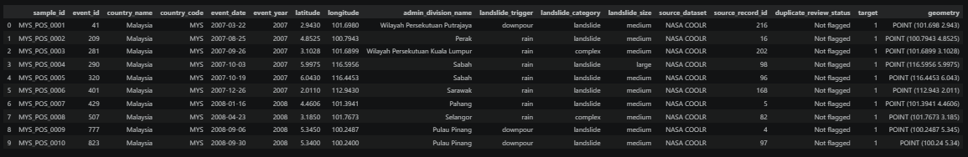
Figure 38 Standardised Malaysia Inventory Sample

Inventory Integration and Validation
The script merges the chosen country inventories into positive events and extended versions of them. It checks sample identifiers, dates, coordinates, geometries, target value and projection system. Country-level record summaries and audit logs are then generated, while bar chart compares the number of cleaned records retained from each candidate country.
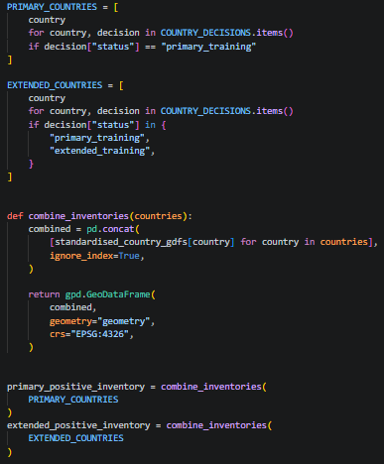 | 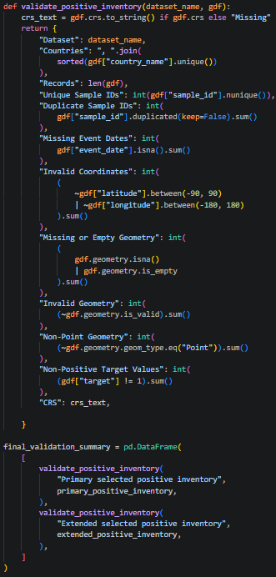
Figure 39 Source Code for Inventory Integration and Technical Validation
The primary inventory consists of 761 records for Malaysia, Indonesia and Thailand, whereas the extended inventory includes 1,539 records, with the addition of the Philippines. There were no records deleted from the inventories during cleaning, and all technical checks have been passed successfully. Singapore remains disqualified, and there are 19 duplicates requiring manual approval before final approval.
Figure 40 Final Inventory Validation Results
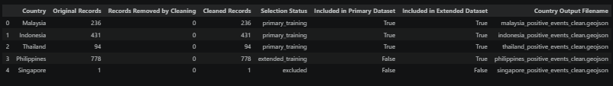
Figure 41 Post-Preprocessing Country Record Counts
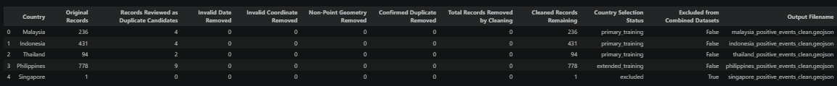
Figure 42 Complete Preprocessing Audit Trail
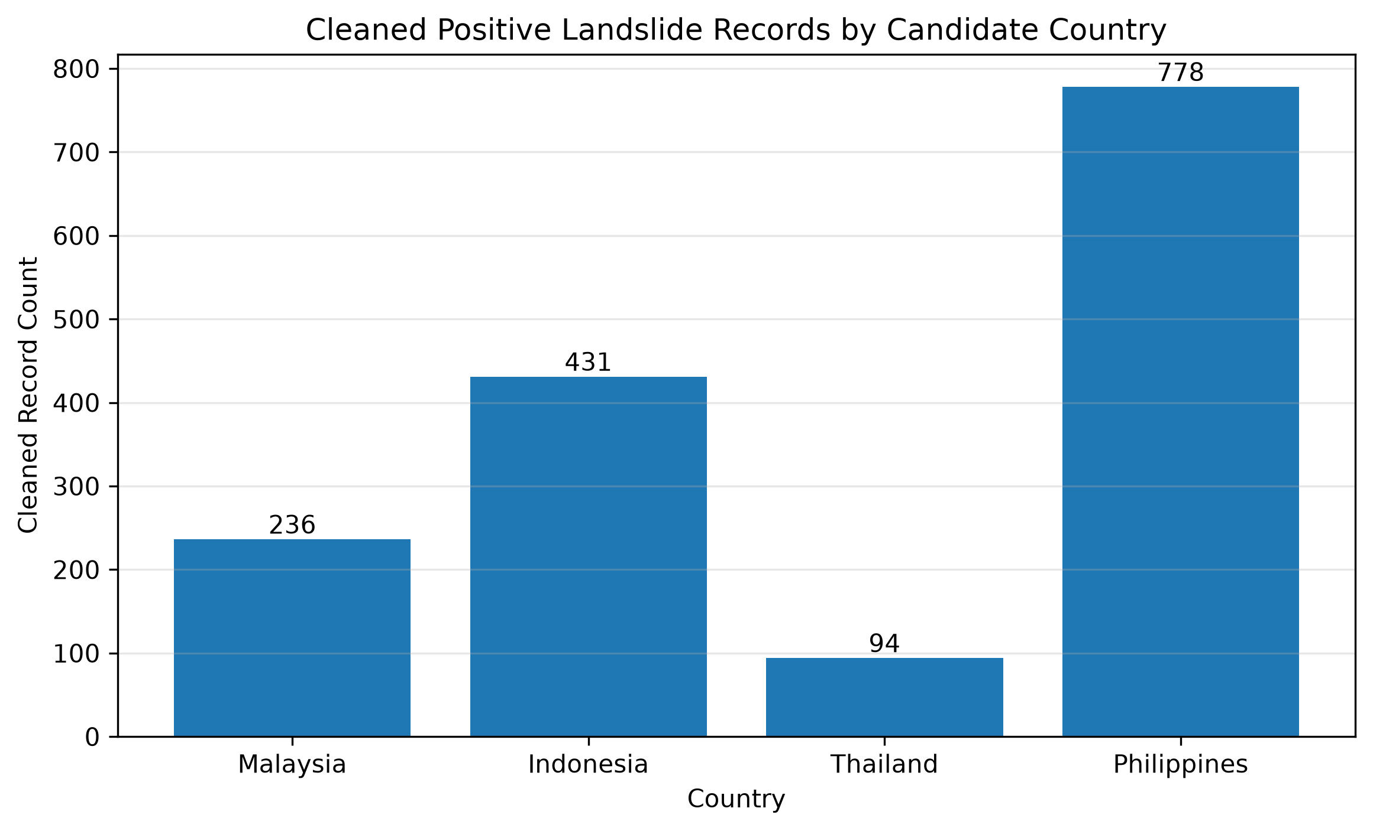
Figure 43 Cleaned Records by Country

Summary
This chapter established the methodological framework for developing the proposed landslide susceptibility decision-support dashboard. CRISP-DM was selected because its iterative and data-centred phases are appropriate for managing the collection, exploration, preparation, modelling, evaluation and deployment of heterogeneous geospatial data. The required data sources were identified, including NASA COOLR landslide records, GPM IMERG rainfall, SRTM terrain data, Dynamic World land cover, OpenStreetMap roads and waterways, and administrative boundaries.
During data understanding, the original Malaysia inventory of 236 records was examined together with candidate inventories from Indonesia, Thailand, the Philippines and Singapore. The analysis assessed their structures, temporal ranges, completeness, event attributes and spatial distributions. Although no exact duplicate records, repeated event identifiers or invalid geometries were found, 19 possible spatial-temporal duplicate candidates were identified for further review. The analysis also revealed unequal record quantities, different observation periods, missing trigger information and substantial spatial clustering. These findings indicate that the inventories cannot be combined automatically without additional selection and standardisation.
The subsequent preprocessing stage therefore focuses on selecting suitable records, reviewing potential duplicates, handling missing or invalid values, standardising schemas and spatial references, preparing environmental layers and constructing the final modelling dataset. The later modelling stage will compare Malaysia-only training with selected combined-country training while retaining the same reserved Malaysian test data. This design will determine whether additional foreign records improve prediction generalisation for Malaysia without changing the final study area.

CHAPTER 4: Conclusion

Achievements of the First Part of the Project
The first part of this project successfully established the research, technical and methodological foundation for developing a semi-dynamic landslide susceptibility decision-support dashboard for Malaysia. The project aim, objectives, scope, target users, benefits and limitations were clearly defined. The investigation also distinguished landslides from a full hazard and risk assessment in order to make sure that the created dashboard will not be seen as an official warning system but as a support decision-making tool.
A comprehensive literature review has been carried out on landslide hazard in Malaysia, inventory limitations, relevant conditioning and triggering factors, machine learning methods, existing landslide systems and suitable development technologies. The review supported the use of rainfall, elevation, slope, aspect, land cover, distance to roads and distance to waterways as candidate factors.
CRISP-DM methodology was chosen to be used in the project, which provides a structured process for data understanding, preparation, modelling, evaluation and deployment. Several required datasets that are needed for the project were also chosen, including NASA COOLR, GPM IMERG, SRTM, Dynamic World, OpenStreetMap and boundary data. Data understanding was conducted on 1,540 candidate records in Malaysia, Indonesia, Thailand, the Philippines and Singapore. The differences in temporal coverage, spatial distribution, missing trigger values and possible duplicate candidates were identified in the analysis. Initial preprocessing of the data was undertaken to facilitate its standardization, integration and validation of the retained records for further feature extraction and modelling.

Adequacy of the Investigation and Research
The investigation and research completed during the first part of the project are considered adequate to proceed further with the proposed system. The study analyzed the requirements of the major domain, technical, data, and methodological aspects associated with landslide susceptibility modelling. The literature review provided sufficient justification for the selected environmental variables and explained the interaction between static conditioning factors and rainfall as a dynamic triggering condition.
The research also compared several machine-learning algorithms such as Logistic Regression, Random Forest, XGBoost, and so on. Logistic Regression and Random Forest were identified as suitable initial models based on the current dataset size, interpretability requirements and project scope. Existing landslide platforms and studies were reviewed in order to suggest functions for a dashboard functions and limitations that should be addressed in the proposed system.
The data understanding stage was sufficiently detailed to highlight important concerns such as uneven record quantities, different temporal ranges, spatial clustering, missing trigger information and possible spatial-temporal duplicates. These findings justify the need for careful preprocessing and spatially aware validation before modelling.
The project also supports Sustainable Development Goal 11 through providing better access to understandable landslide susceptibility information for preparedness, awareness and preliminary planning. However, the system will not replace official warnings, engineering assessments or emergency decisions, which will only remain a prototype decision-support system. Overall, the completed investigation provides a sufficient foundation for feature extraction, model training, evaluation and dashboard development.

Research and Design Gaps for Further Improvement
Several gaps still need to be addressed during the next part of the project:
- Limited Malaysian landslide inventory
The 236 Malaysian records may not fully represent all historical landslides because of incomplete reporting, uneven coverage and possible coordinate uncertainty.
- Cross-country comparability
Use of foreign cases may help increase the number of samples, but differences in terrain, reporting practices, temporal coverage and environmental conditions must be evaluated when combining them with Malaysian data.
- Pseudo-absence sample generation
The inventory does not contain confirmed non-landslide records. Control samples must therefore be generated carefully since missing information of an event does not imply that there was no landslide.
- Environmental feature extraction
Rainfall accumulation, elevation, slope, aspect, land cover and distance to road or waterways variables still need to be extracted, spatially aligned and validated.
- Spatial data leakage
The results using random split for training and testing might be overly optimistic since nearby records can share similar environmental conditions. Therefore, grouped or spatial validation needs to be conducted.
- Model interpretation
The final model should provide understandable explanations through feature importance or other interpretation techniques.
- Dashboard usability and communication
The interface must clearly distinguish susceptibility from rainfall-based warning conditions and explain that the results are not official warnings.
- Additional environmental limitations
Information of geological, soil, groundwater and slope monitoring may not be consistently available at the national scale and should be acknowledged as limitations.

References
Abd Rasid Jaapar, Mohamad, Ibrahim Komoo, Che Aziz Ali, Zamri Ramli, Abd Rahim Harun, Bachat, J., Mohamad, Z., Rohayu Che Omar, Khamarrul Azahari Razak, & Choun Sian Lim. (2023). The Emerging Widespread Debris Flow Disasters in Tropical Terrain of Peninsular Malaysia: Understanding the Risk and Policy Intervention. E3S Web of Conferences, 415, 05008–05008. https://doi.org/10.1051/e3sconf/202341505008
Ado, M., Amitab, K., Maji, A. K., Jasińska, E., Gono, R., Leonowicz, Z., & Jasiński, M. (2022). Landslide Susceptibility Mapping Using Machine Learning: A Literature Survey. Remote Sensing, 14(13), 3029. https://doi.org/10.3390/rs14133029
Affandi, E., Ng, T. F., Pereira, J. J., Ahmad, F., & Banks, V. J. (2023). Revalidation Technique on Landslide Susceptibility Modelling: An Approach to Local Level Disaster Risk Management in Kuala Lumpur, Malaysia. Applied Sciences, 13(2), 768. https://doi.org/10.3390/app13020768
AlAbdulaali, A., Asif, A., Khatoon, S., & Alshamari, M. (2022). Designing Multimodal Interactive Dashboard of Disaster Management Systems. Sensors, 22(11), 4292. https://doi.org/10.3390/s22114292
Analytics Vidhya. (2025). Complete Guide to Parameter Tuning in XGBoost (With Codes in Python). In Analytics Vidhya. https://www.analyticsvidhya.com/blog/2016/03/complete-guide-parameter-tuning-xgboost-with-codes-python/
Ari Lamstein. (2026, January 26). GeoPandas Basics: Maps, Projections, and Spatial Joins. Real Python. Realpython. https://realpython.com/geopandas/
Basheer, R., Rahmawati, S. S. Y., Lee, M., Rashid, N. B. M., Azhari, N. S. B., & Hussain, K. (2025, February 13). Data Retrieval Machine Learning Approaches for Enhancing Denial of Service Attack Detection in Industrial Control Systems. https://papers.ssrn.com/sol3/papers.cfm?abstract_id=5136845
Buhl, N. (2023). Logistic Regression: Definition, Use Cases, Implementation. In encord.com. https://encord.com/blog/what-is-logistic-regression/
Chmielewski, R., Aleksandra Bąk, Paweł Muzolf, & Sobczyk, K. (2024). Influence of Calculation Parameters on the Slope Stability of the Historical Rasos Cemetery in Vilnius (Lithuania). Sustainability, 16(7), 2891–2891. https://doi.org/10.3390/su16072891
Coursera Staff. (2024). What is NumPy? In Coursera. https://www.coursera.org/articles/what-is-numpy
Daniel, M. T., Ng, T. F., Abdul Kadir, Mohd. F., & Pereira, J. J. (2021). Landslide Susceptibility Modeling Using a Hybrid Bivariate Statistical and Expert Consultation Approach in Canada Hill, Sarawak, Malaysia. Frontiers in Earth Science, 9. https://doi.org/10.3389/feart.2021.616225
Deng, N., Li, Y., Ma, J., Shahabi, H., Hashim, M., de Oliveira, G., & Chaeikar, S. S. (2022). A comparative study for landslide susceptibility assessment using machine learning algorithms based on grid unit and slope unit. Frontiers in Environmental Science, 10. https://doi.org/10.3389/fenvs.2022.1009433
Dou, H., He, J., Huang, S., Jian, W., & Guo, C. (2023). Influences of non-landslide sample selection strategies on landslide susceptibility mapping by machine learning. Geomatics, Natural Hazards and Risk, 14(1). https://doi.org/10.1080/19475705.2023.2285719
Dwivedi, A., & Jaiswal, A. (2021). Recent Trends in Programming Languages. Python: The Versatile Language - Recent Trends in Programming Languages. https://doi.org/10.37591/rtpl
Edrich, A.-K., Yildiz, A., Roscher, R., Bast, A., Graf, F., & Kowalski, J. (2024). A modular framework for fair shallow landslide susceptibility mapping based on machine learning. Natural Hazards, 120(9), 8953–8982. https://doi.org/10.1007/s11069-024-06563-8
Eu, S., Seo, J., Lee, K., Woo, C., & Lee, C. (2024). Nonstructural landslide mitigation of the Republic of Korea. Landslides, 22(3), 763–772. https://doi.org/10.1007/s10346-024-02445-z
Fleischmann, M., Van den Bossche, J., Jordahl, K., Richards, M. J., McBride, J., Wasserman, J., Ward, B., & Wolf, L. J. (2026). GeoPandas: Fundamental data structures for vector spatial data in Python. Computers, Environment and Urban Systems, 130, 102495. https://doi.org/10.1016/j.compenvurbsys.2026.102495
Geofabrik. (2025a). Download openstreetmap for indonesia (with east timor) | geofabrik download server. In Geofabrik Download Server. https://download.geofabrik.de/asia/indonesia.html
Geofabrik. (2025b). Download OpenStreetMap for Philippines | Geofabrik Download Server. In Geofabrik Download Server. https://download.geofabrik.de/asia/philippines.html
Geofabrik. (2025c). Geofabrik download server. In Geofabrik.de. https://download.geofabrik.de/asia/malaysia-singapore-brunei.html
Geofabrik. (2026). Download OpenStreetMap for Thailand | Geofabrik download server. In Geofabrik Download Server. https://download.geofabrik.de/asia/thailand.html
Googel Earth Engine. (n.d.). Dynamic world v1 | earth engine data catalog. In Google Developers. Retrieved 3 August 2026, from https://developers.google.com/earth-engine/datasets/catalog/GOOGLE_DYNAMICWORLD_V1
Google Earth Engine. (2023). Image collections. In Google for Developers. https://developers.google.com/earth-engine/tutorials/tutorial_api_04
Google Earth Engine. (2025a). GPM: Global Precipitation Measurement (GPM) Release 07 | Earth Engine Data Catalog | Google for Developers. In Google for Developers. https://developers.google.com/earth-engine/datasets/catalog/NASA_GPM_L3_IMERG_V07
Google Earth Engine. (2025b). NASA SRTM Digital Elevation 30m | Earth Engine Data Catalog | Google for Developers. In Google for Developers. https://developers.google.com/earth-engine/datasets/catalog/USGS_SRTMGL1_003
Graser, A., Sutton, T., & Bernasocchi, M. (2025). The QGIS Project: Spatial Without Compromise. Patterns, 101265. https://doi.org/10.1016/j.patter.2025.101265
Hou, S., Jiao, H., Liu, Z., Xie, L., Chen, G., Wu, S., Guan, X., & Wu, H. (2026). GeoSQL-Eval: First Evaluation of LLMs on PostGIS-based NL2GeoSQL Queries. Expert Systems with Applications, 320, 132122. https://doi.org/10.1016/j.eswa.2026.132122
Huang, Y., Zheng, M., Li, T., Xiao, F., & Zheng, X. (2024). An Integrated Framework for Landscape Indices’ Calculation with Raster–Vector Integration and Its Application Based on QGIS. ISPRS International Journal of Geo-Information, 13(7), 242–242. https://doi.org/10.3390/ijgi13070242
Hussain, M. A., Chen, Z., Zheng, Y., Zhou, Y., & Daud, H. (2023). Deep Learning and Machine Learning Models for Landslide Susceptibility Mapping with Remote Sensing Data. Remote Sensing, 15(19), 4703. https://doi.org/10.3390/rs15194703
Iadanza, C., Trigila, A., Starace, P., Dragoni, A., Biondo, T., & Roccisano, M. (2021). IdroGEO: A collaborative web mapping application based on REST API services and open data on landslides and floods in Italy. ISPRS International Journal of Geo-Information, 10(2), 89. https://doi.org/10.3390/ijgi10020089
IBM. (n.d.). IBM SPSS Modeler CRISP-DM Guide. Retrieved 3 August 2026, from https://www.ibm.com/docs/en/SS3RA7_18.6.0/pdf/ModelerCRISPDM.pdf?
Irawan, L. Y., Prasetyo, W. E., Meganagatha, M., Rosbella Devy, Damar Panoto, Irfan Helmi Pradana, & Dicky Arinta. (2024). Developing a real-time detection and visualization of landslide hazards using web-GIS: A case study in Pacet, Mojokerto, East Java, Indonesia. AIP Conference Proceedings. https://doi.org/10.1063/5.0184132
Jun, S. W. (2024, October 16). Selangor MB: Taman Melawati landslide due to clogged drains, not over-development. Malay Mail. Malay Mail . https://www.malaymail.com/news/malaysia/2024/10/16/selangor-mb-taman-melawati-landslide-due-to-clogged-drains-not-over-development/153796
Kang, J., Wan, B., Gao, Z., Zhou, S., Chen, H., & Shen, H. (2024). Research on machine learning forecasting and early warning model for rainfall-induced landslides in Yunnan province. Scientific Reports, 14(1). https://doi.org/10.1038/s41598-024-64679-0
Khan, S., Kirschbaum, D. B., Stanley, T. A., Amatya, P. M., & Emberson, R. A. (2022). Global Landslide Forecasting System for Hazard Assessment and Situational Awareness. Frontiers in Earth Science, 10. https://doi.org/10.3389/feart.2022.878996
Le, X.-H., Choi, C., Eu, S., Yeon, M., & Lee, G. (2024). Quantitative evaluation of uncertainty and interpretability in machine learning-based landslide susceptibility mapping through feature selection and explainable AI. Frontiers in Environmental Science, 12. https://doi.org/10.3389/fenvs.2024.1424988
Lee, S., Roh, M., Jo, H.-W., Joon, K., & Lee, W.-K. (2025). machine learning-based rainfall-induced landslide susceptibility model and short-term early warning assessment in South Korea. Landslides. https://doi.org/10.1007/s10346-025-02513-y
Lim, J., Santinelli, G., Dahal, A., Vrieling, A., & Lombardo , L. (2024). An ensemble neural network approach for space–time landslide predictive modelling. International Journal of Applied Earth Observation and Geoinformation, 132, 104037. https://doi.org/10.1016/j.jag.2024.104037
Lin, Q., Lima, P., Steger, S., Glade, T., Jiang, T., Zhang, J., Liu, T., & Wang, Y. (2021). National-scale data-driven rainfall induced landslide susceptibility mapping for China by accounting for incomplete landslide data. Geoscience Frontiers, 12(6), 101248. https://doi.org/10.1016/j.gsf.2021.101248
Lu, M., Lea Tien Tay, & Mohamad-Saleh, J. (2024). Landslide susceptibility analysis using random forest model with SMOTE-ENN resampling algorithm. Geomatics Natural Hazards and Risk, 15(1). https://doi.org/10.1080/19475705.2024.2314565
Lu, Z., Liu, G., Song, Z., Sun, K., Li, M., Chen, Y., Zhao, X., & Zhang, W. (2024). Advancements in Technologies and methodologies of Machine learning in Landslide susceptibility research: Current trends and future directions. Applied Sciences, 14(21), 9639. https://doi.org/10.3390/app14219639
Lydon, J. (2021, May 19). Introducing Google Earth Engine. Síor Consulting. https://siorconsulting.com/2021/05/19/introducing-google-earth-engine/
Martin, D., & Chai, S. S. (2022). A Study on Development of Landslide Susceptibility Map in Malaysia Landslide Prone Areas by Using Geographic Information System (GIS) and Machine Learning. https://ieeexplore.ieee.org/document/9781943
Maturidi, A. M. A. M., Kasim, N., Abu Taib, K., & Wan Azahar, W. N. A. (2021). Rainfall-Induced Landslide Thresholds Development by Considering Different Rainfall Parameters: A Review. Journal of Ecological Engineering, 22(10), 85–97. https://doi.org/10.12911/22998993/142183
Mhadhbi, N. (2026). Python tutorial: Streamlit. In www.datacamp.com. https://www.datacamp.com/tutorial/streamlit
Mohd Noh, M. R., Mohamed, T. R. T., Ahmad, F., Harun, A. R., Ramli, Z., & Rosle, Q. A. (2024, December 29). Geological Factors Contributing to Landslide Incident in Malaysia - Case Study Batang Kali Landslide Disaster, Hulu Selangor, Selangor. https://ph03.tci-thaijo.org/index.php/TGJ/article/view/1966
Murthy, T., Izham Mohamad Yusoff, Siti Hamsah Samsudin, Majid, T. A., Ismail Ahmad Abir, Yong, C. H., & Mohd. (2023). Geographical Information System (GIS)-Based Landslide Susceptibility Mapping in Malaysia: A Review of Past, Current and Future Trends. Academic Journal of Interdisciplinary Studies, 12(3), 162–162. https://doi.org/10.36941/ajis-2023-0069
NASA. (2025). Coolr | NASA Global Precipitation Measurement Mission. In Nasa.gov. https://gpm.nasa.gov/applications/landslides/coolr
Natural Earth. (n.d.). Natural Earth » Blog Archive » Admin 0 – Countries - Free vector and raster map data at 1:10m, 1:50m, and 1:110m scales. Retrieved 3 August 2026, from https://www.naturalearthdata.com/downloads/10m-cultural-vectors/10m-admin-0-countries/
Nebius. (2025). What is Jupyter Notebook? Why It’s essential for AI and data science. In Nebius.com. https://nebius.com/blog/posts/what-is-jupyter-notebook-for-ai
Plotly. (2023). Plotly Python Graphing Library. In plotly.com. https://plotly.com/python/
Qiusheng Wu. (2025). 11. Rasterio — Introduction to GIS Programming. In Gishub.org. https://geog-312.gishub.org/book/geospatial/rasterio.html
Renata Pacheco Quevedo, Andrés Velastegui-Montoya, Néstor Montalván-Burbano, Morante-Carballo, F., Korup, O., & Camilo Daleles Rennó. (2023). Land use and land cover as a conditioning factor in landslide susceptibility: a literature review. Landslides, 20. https://doi.org/10.1007/s10346-022-02020-4
Rosedin, N. N., Rasam, A. R. A., Hashim, N., Shaharudin, E. S., & Wahab, S. R. H. A. (2026). HARNESSING ASTER-DEM-DERIVED WATERSHED FEATURES FOR LANDSLIDE SUSCEPTIBILITY MAPPING | Journal of Civil Engineering, Science and Technology. Unimas.My. https://publisher.unimas.my/ojs/index.php/JCEST/article/view/8975
Sagar, P. (2024, June 8). Most Used Matplotlib Plots in Data Science. Medium. https://medium.com/@pritisagar0427/most-used-matplotlib-plots-in-data-science-d1cea47fe93a
Salazar, J. J., Garland, L., Ochoa, J., & Pyrcz, M. J. (2022). Fair train-test split in machine learning: Mitigating spatial autocorrelation for improved prediction accuracy. Journal of Petroleum Science and Engineering, 209, 109885. https://doi.org/10.1016/j.petrol.2021.109885
SAS. (2025). Introduction to SEMMA. In Sas.com. https://documentation.sas.com/doc/en/emref/15.3/n061bzurmej4j3n1jnj8bbjjm1a2.htm
Schlögl, M., Graser, A., Spiekermann, R., Lampert, J., & Steger, S. (2025). Brief communication: Visualizing uncertainties in landslide susceptibility modelling using bivariate mapping. Natural Hazards and Earth System Sciences, 25(4), 1425–1437. https://doi.org/10.5194/nhess-25-1425-2025
Scikit-learn. (2026). 11. Model Persistence. In scikit-learn. https://scikit-learn.org/stable/model_persistence.html
Selamat, S. N., Abd Majid, N., & Mohd Taib, A. (2023). A Comparative Assessment of Sampling Ratios Using Artificial Neural Network (ANN) for Landslide Predictive Model in Langat River Basin, Selangor, Malaysia. Sustainability, 15(1), 861. https://doi.org/10.3390/su15010861
Selamat, S. N., Majid, N. A., Taha, M. R., & Osman, A. (2022a). Application of geographical information system (GIS) using artificial neural networks (ANN) for landslide study in Langat Basin, Selangor. IOP Conference Series: Earth and Environmental Science, 1064(1), 012052. https://doi.org/10.1088/1755-1315/1064/1/012052
Selamat, S. N., Majid, N. A., Taha, M. R., & Osman, A. (2022b). Landslide Susceptibility Model Using Artificial Neural Network (ANN) Approach in Langat River Basin, Selangor, Malaysia. Land, 11(6), 833. https://doi.org/10.3390/land11060833
Shimaoka, A. M., Ferreira, R. C., & Goldman, A. (2024). The evolution of Crisp-Dm for Data science: Methods, processes and frameworks. SBC Reviews on Computer Science, 4(1), 28–43. https://www.researchgate.net/publication/384999724_The_Evolution_of_CRISP-DM_for_Data_Science_Methods_Processes_and_Frameworks
Shrivastava, A. (2026a, May 21). How to Use Shapely for Geospatial Data Processing in Python. Lizardtech. https://www.lizardtech.com/post/how-to-use-shapely-for-geospatial-data-processing-in-python
Shrivastava, A. (2026b, May 26). Getting Started with Pyproj in Python. Lizardtech. https://www.lizardtech.com/post/getting-started-with-pyproj-in-python
Stanley, T., Kirschbaum, D., Benz, G., Emberson, R., Pukar Amatya, Medwedeff, W., & Clark, M. K. (2021). Data-Driven Landslide Nowcasting at the Global Scale. Frontiers in Earth Science, 9. https://doi.org/10.3389/feart.2021.640043
Stifi, M. (2024). A Comprehensive Guide to scikit-learn: Unlocking the Power of Python for Machine Learning | Medium. In Medium. https://mohamed-stifi.medium.com/exploring-scikit-learn-a-comprehensive-overview-of-its-sub-packages-and-modules-032bea32a65f
Streamlit. (2024). Streamlit Community Cloud - Streamlit Docs. In Streamlit.io. https://docs.streamlit.io/deploy/streamlit-community-cloud
subMit. (2021). Conda and Its Benefits Beyond Python — SubMIT v1 Documentation. Mit.Edu. https://submit.mit.edu/submit-users-guide/conda.html
Suma, K. G., Gurram Sunitha, J. Avanija, Mohammad Gouse Galety, & Chinthapatla Pranay Varna. (2024). Geospatial Data Visualization with Folium. Advances in Geospatial Technologies Book Series, 187–208. https://doi.org/10.4018/979-8-3693-1754-9.ch007
Suma Katabattuni. (2024). Why Choose Streamlit? A Comprehensive Guide - Suma Katabattuni - Medium. In Medium. https://medium.com/@sumakbn/why-choose-streamlit-a-comprehensive-guide-bc4779ff678c
Syams, M. N. E., Ibrahim, I., Latif, N. A., M Zainora Asmawi, & Siti Aekbal Salleh. (2025). LANDSLIDE SUSCEPTIBILITY ANALYSIS USING REMOTE SENSING AND GIS: A CASE STUDY IN HULU LANGAT, SELANGOR, MALAYSIA. Planning Malaysia, 23. https://doi.org/10.21837/pm.v23i35.1676
Tan, J., Yang, C., Wang, Y., Xiong, H., & Ma, C. (2024). A hybrid model to overcome landslide inventory incompleteness issue for landslide susceptibility prediction. Geocarto International, 39(1). https://doi.org/10.1080/10106049.2024.2322066
Tengtrairat, N., Woo, W. L., Parathai, P., Aryupong, C., Jitsangiam, P., & Rinchumphu, D. (2021). Automated Landslide-Risk Prediction Using Web GIS and Machine Learning Models. Sensors, 21(13), 4620. https://doi.org/10.3390/s21134620
The Star. (2025, December 5). Landslide damages eight houses in Gombak village following heavy rain. The Star. https://www.thestar.com.my/news/nation/2025/12/05/landslide-damages-eight-houses-in-gombak-village-following-heavy-rain
Training the Street. (2025, July 10). What is Pandas - Training the Street - Financial Training, Finance Training, Investment Banking Training, Financial Modeling Training. Training The Street - Financial Training, Finance Training, Investment Banking Training, Financial Modeling Training. https://trainingthestreet.com/resources/what-is-pandas/
Ullah, I., Aslam, B., Shah, S. H. I. A., Tariq, A., Qin, S., Majeed, M., & Havenith, H.-B. (2022). An Integrated Approach of Machine Learning, Remote Sensing, and GIS Data for the Landslide Susceptibility Mapping. Land, 11(8), 1265. https://doi.org/10.3390/land11081265
Vasilis Kalyvas. (2025). “MLshorts” 35: Limitations of Random Forests. In Medium. AI Mind. https://pub.aimind.so/mlshorts-35-limitations-of-random-forests-734252141938
Visual Studio Code. (2026a). Debugging Configurations for Python Apps in Visual Studio Code. In code.visualstudio.com. https://code.visualstudio.com/docs/python/debugging
Visual Studio Code. (2026b). Using Python Environments in Visual Studio Code. In code.visualstudio.com. https://code.visualstudio.com/docs/python/environments
Visual Studio Code. (2026c). Working with Jupyter code cells in the Python Interactive window. In code.visualstudio.com. https://code.visualstudio.com/docs/python/jupyter-support-py
Zulkafli, S. A., Majid, N. A., & Rainis, R. (2023). Spatial Analysis on the Variances of Landslide Factors Using Geographically Weighted Logistic Regression in Penang Island, Malaysia. In Mdpi.com. https://www.mdpi.com/2071-1050/15/1/852

Appendix

Appendix A: PPF – Title Registration Proposal
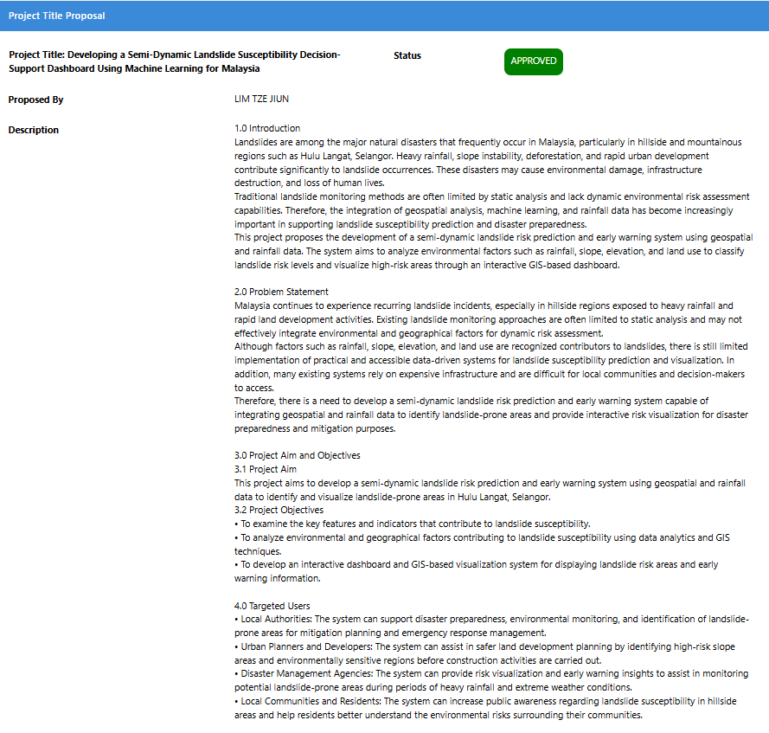

Figure 44 PPF-Title Registration Proposal

Appendix B: Ethics Forms (Fast Track)
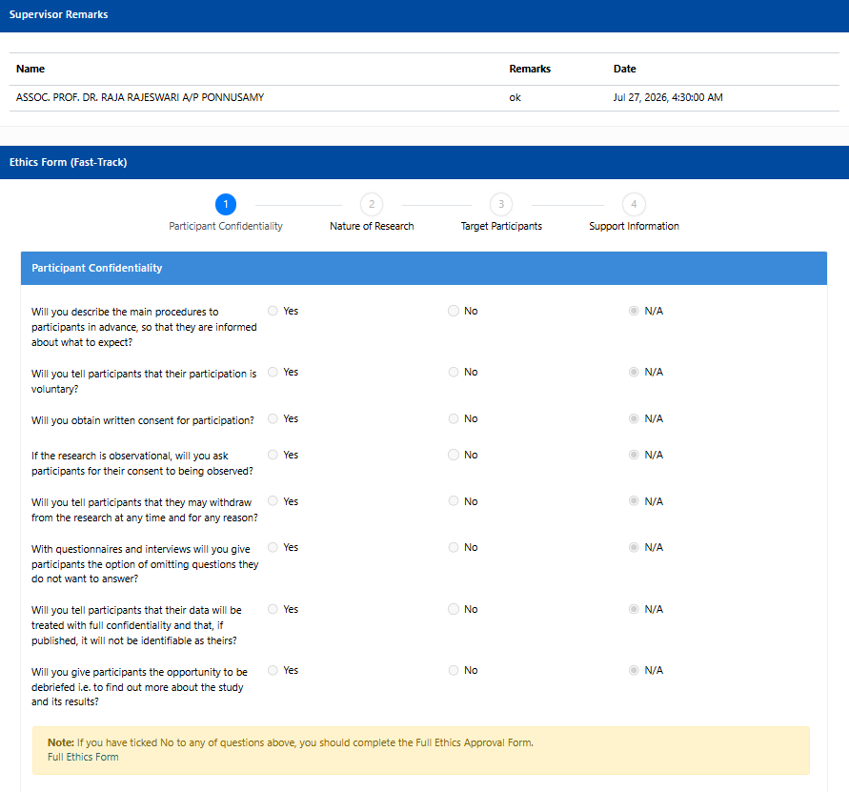
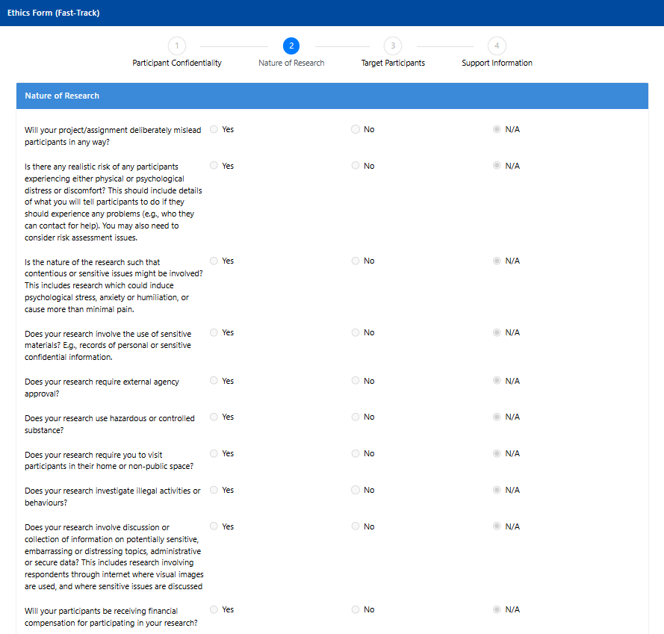

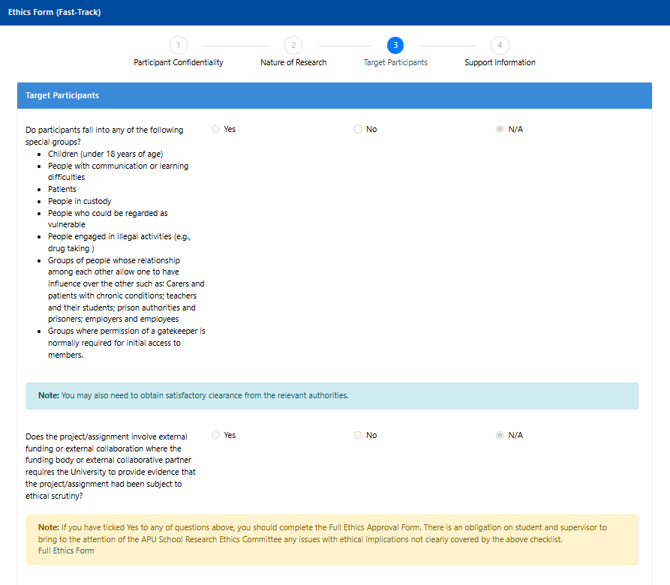

Figure 45 Ethics Form

Appendix C: Log Sheets
Log Sheet 1
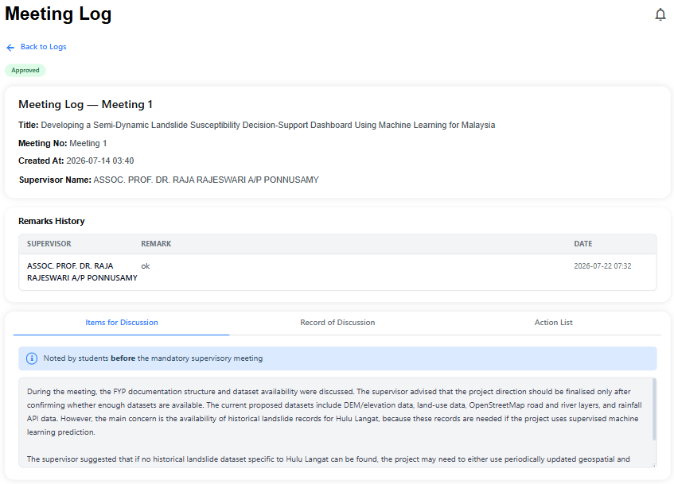

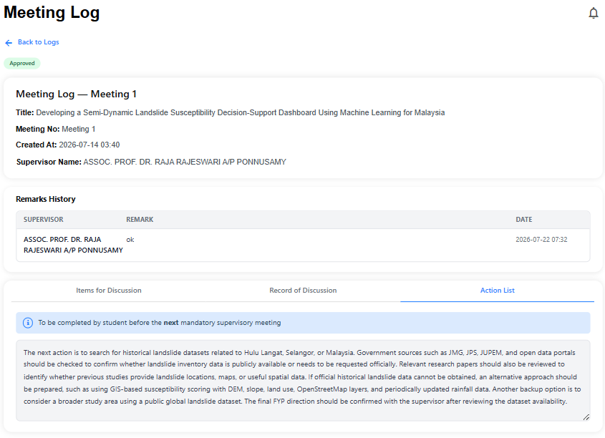
Figure 46 Log Sheet 1
Log Sheet 2

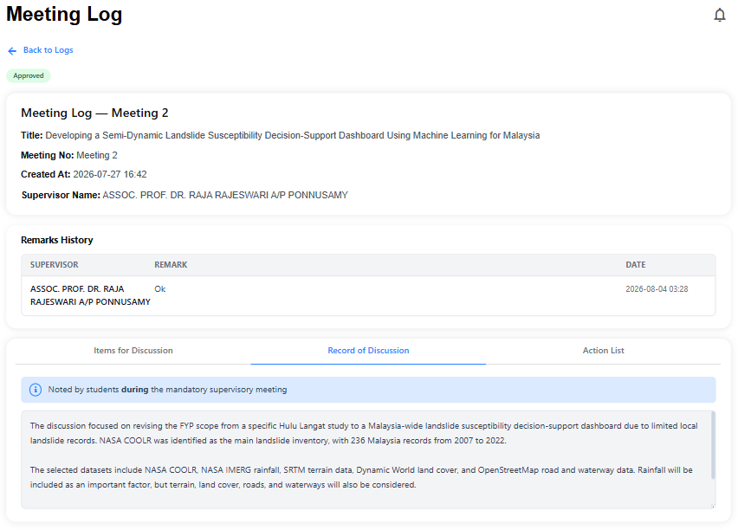
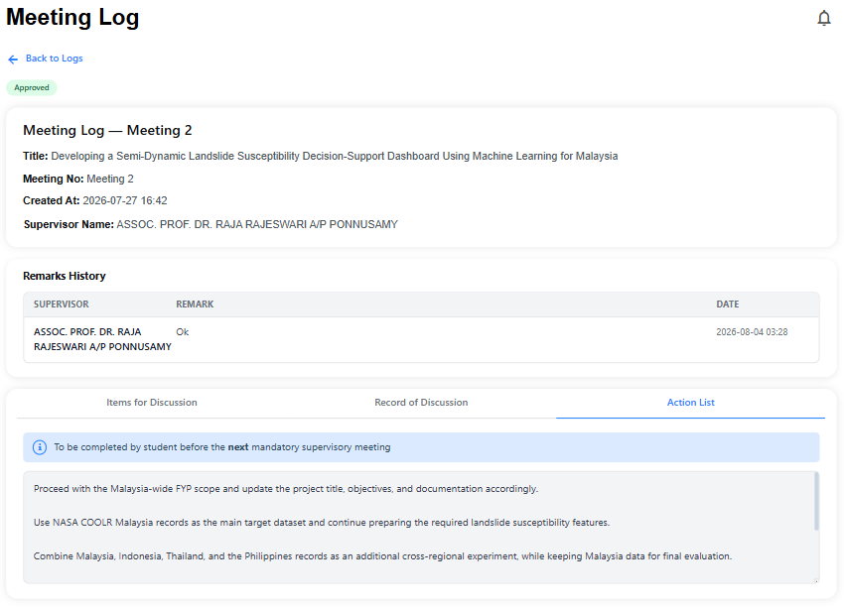
Figure 47 Log Sheet 2
Log Sheet 3



Figure 48 Log Sheet 3

Appendix D: Gantt Chart
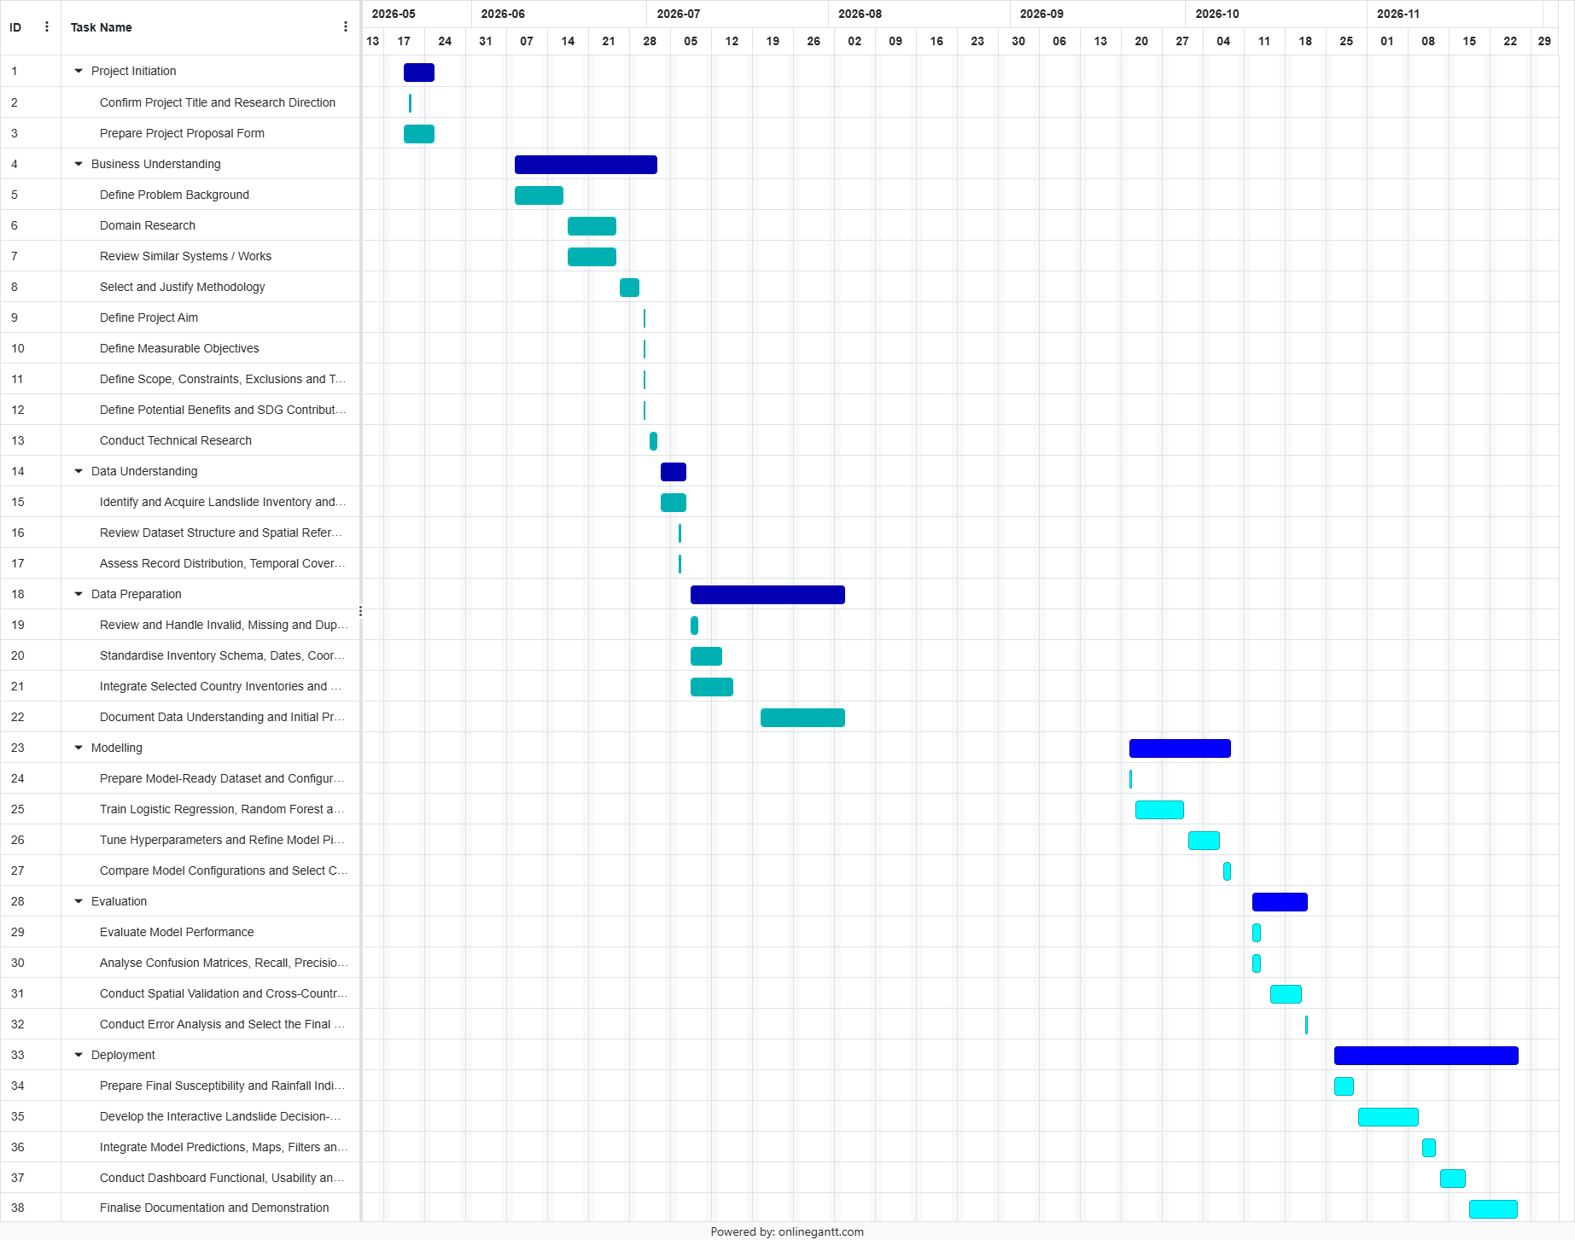
Figure 49 Gantt Chart

Appendix E: Turnitin Similarity Report


Figure 50 Turnitin Similarity Report

